Core 3 Functions Questions
(From the Oxford MAT Tests)

For answers, see the MAT website

2007, Question 2:

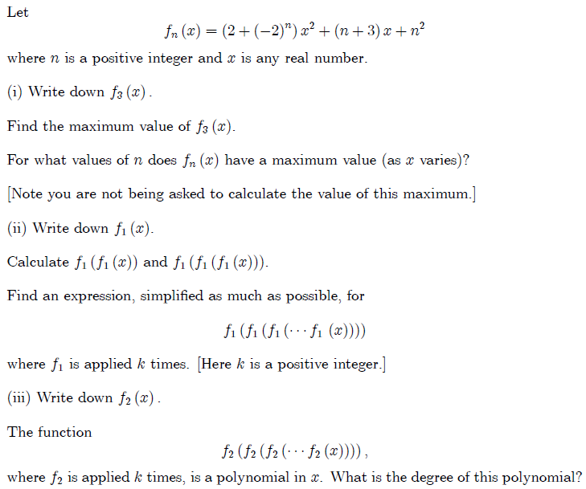

2008, Question 3:

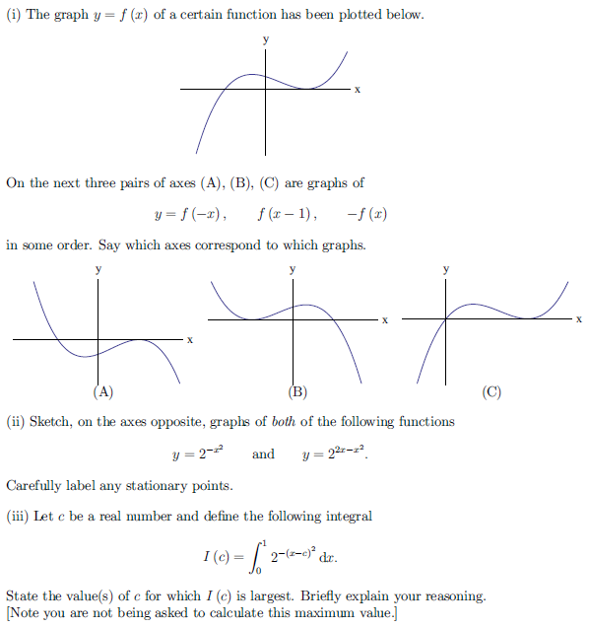

2009, Question 3:

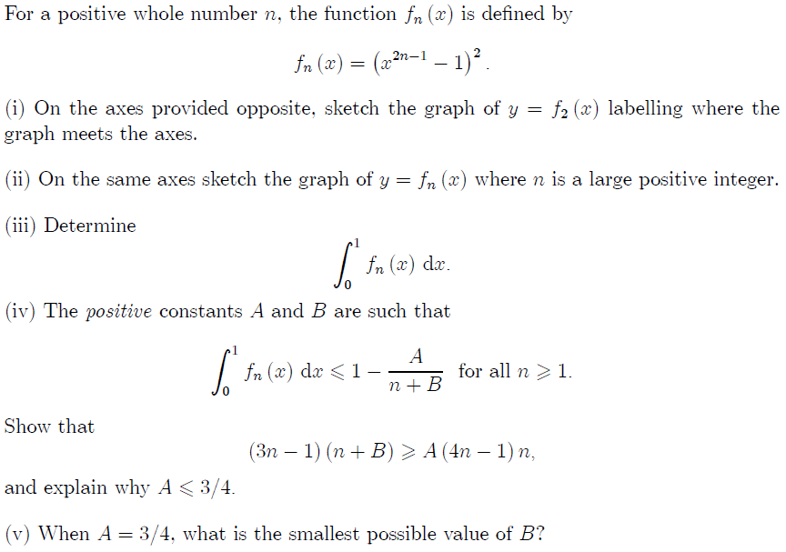

2009, Question 4:

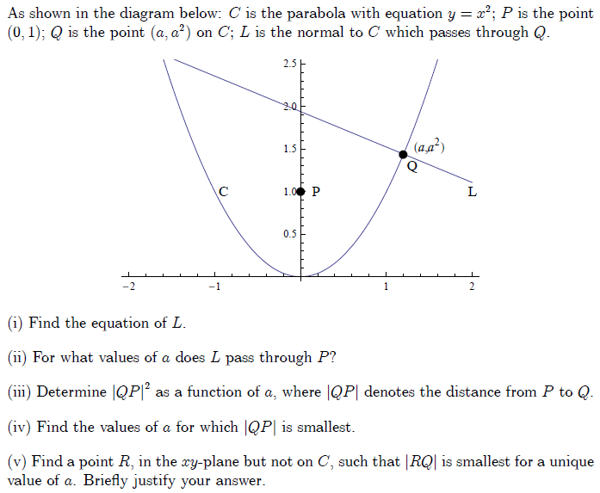

2010, Question 1g:

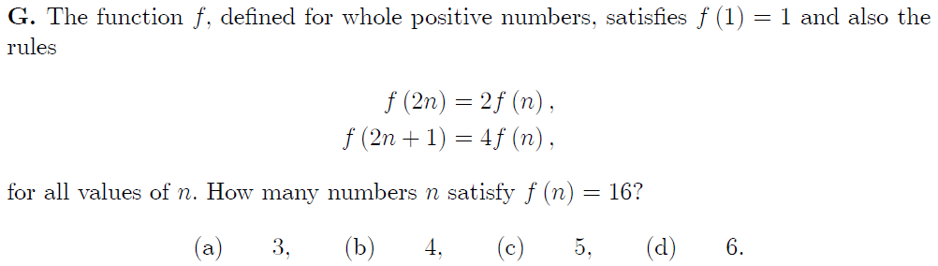

2011, Question 1g:

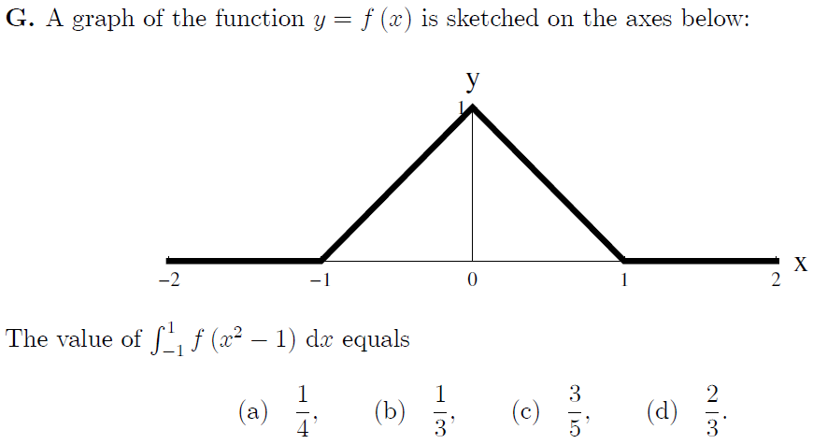

2011, Question 1j:

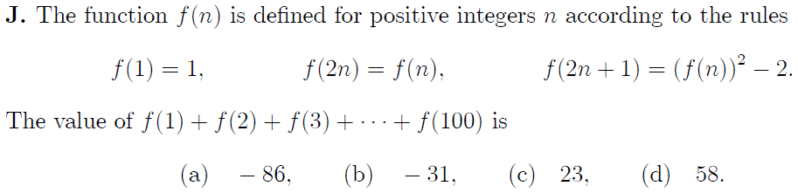

2012, Question 2:

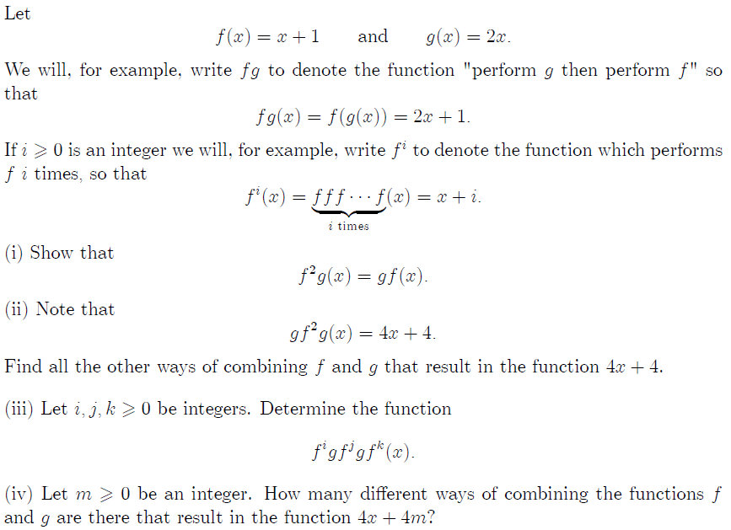

2013, Question 1c:

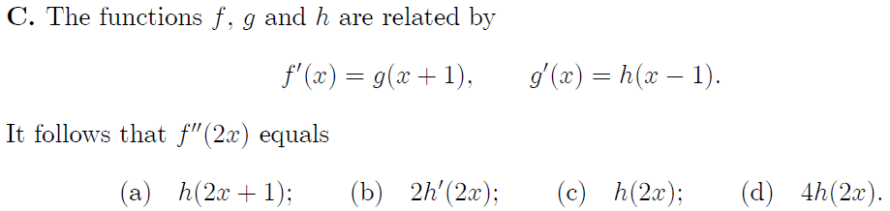

2013, Question 1i:

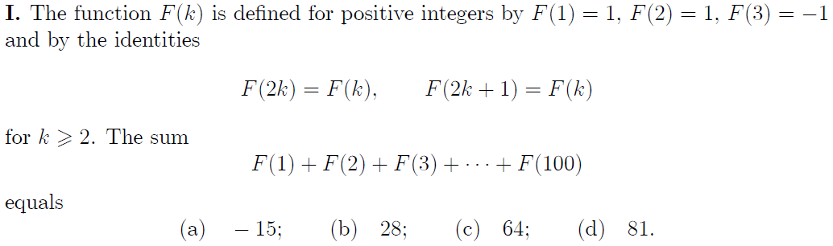

2013, Question 2:

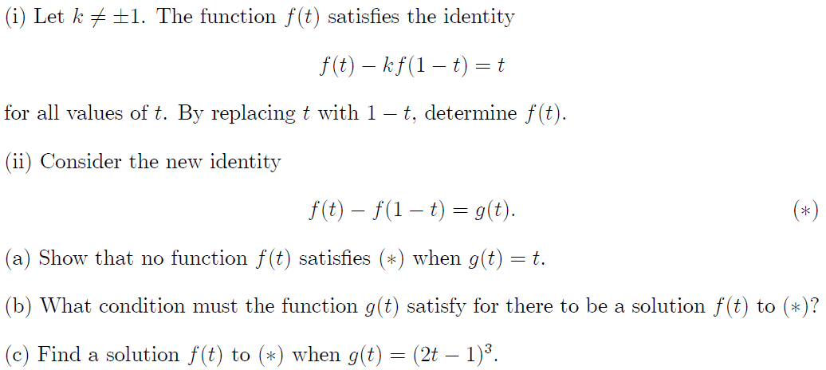

2014, Question 1f:

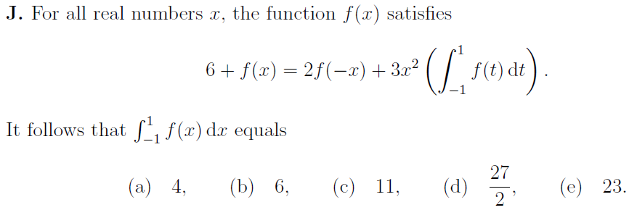

2014, Question 1h:

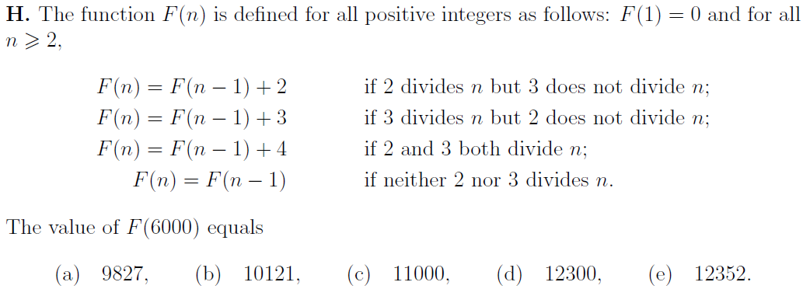

2014, Question 1j:

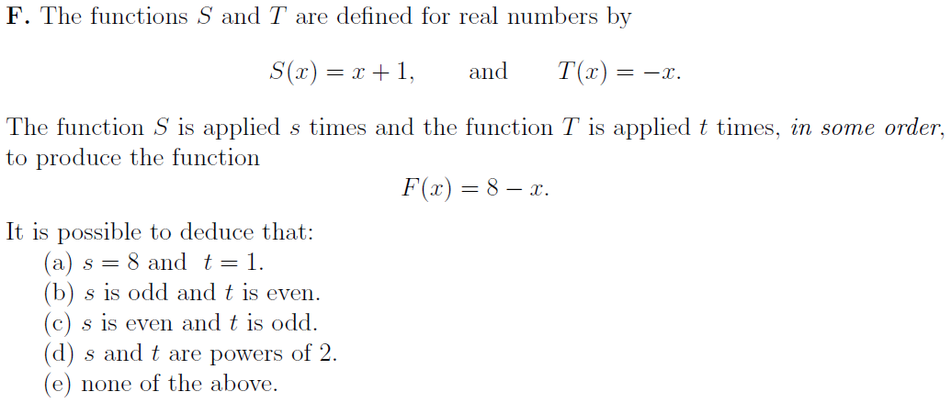

2014, Question 3:

