4² Great Mathematics Reading Books for Sixth-formers

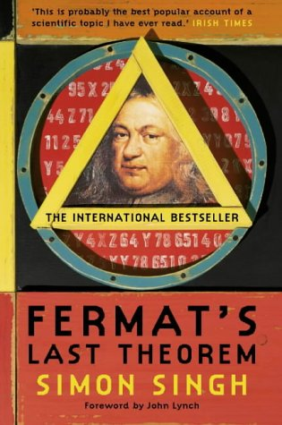 | Fermat’s Last Theorem - Simon Singh | 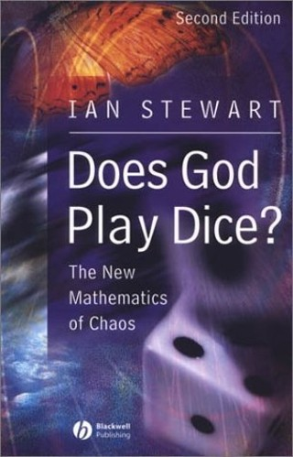 | Does God Play Dice - Ian Stewart | 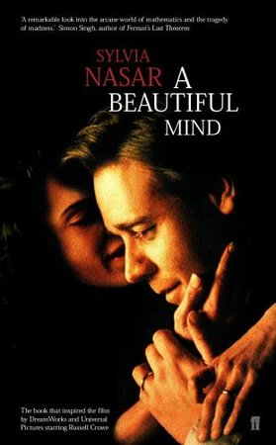 | A Beautiful Mind - Sylvia Nasar | 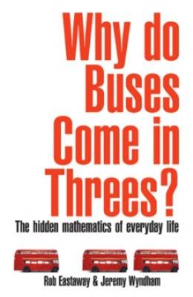 | Why Do Buses Always Come in Threes – Rob Eastaway
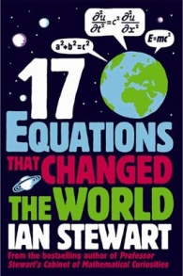 | 17 Equations that Changed the World – Ian Stewart | 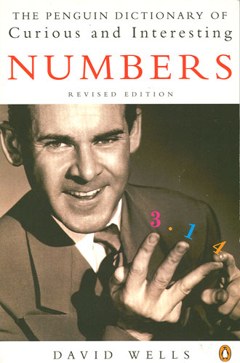 | The Penguin Book of Curious and Interesting Numbers - David Wells | 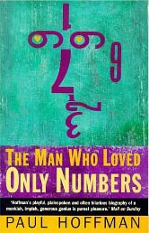 | The Man Who Loved Only Numbers – Paul Hoffman | 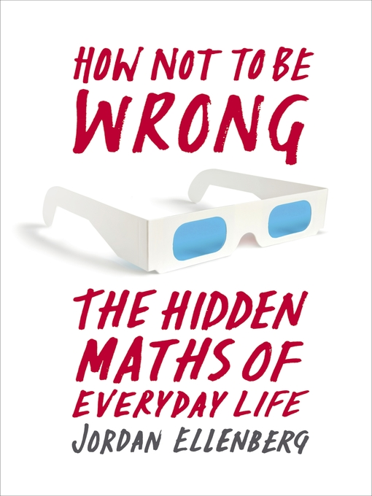 | How To Not Be Wrong – Jordan Ellenberg
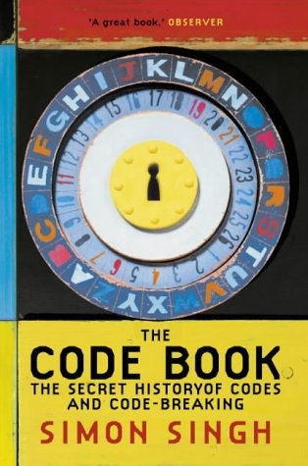 | The Code Book - Simon Singh | 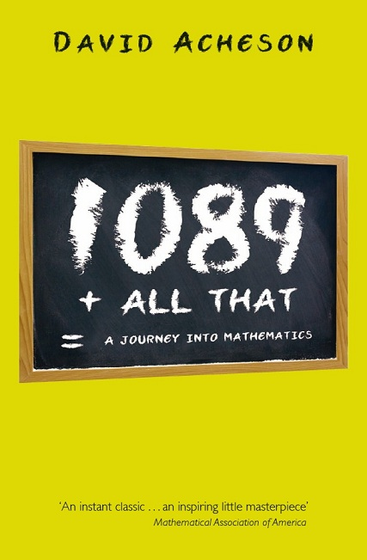 | 1089 And All That - David Acheson | 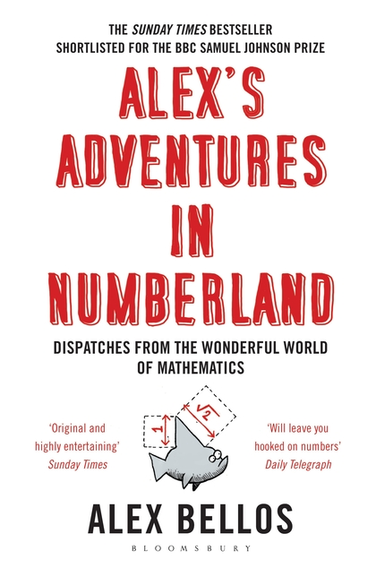 | Alex’s Adventures in Numberland – Alex Bellos | 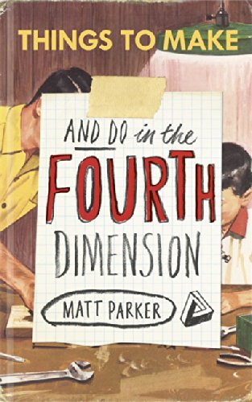 | Things to Make & Do in the 4th Dimension – Matt Parker
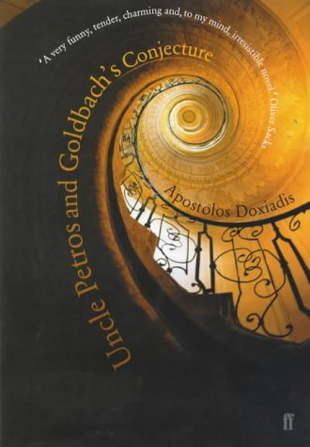 | Uncle Petros and Goldbach’s Conjecture - Apostolos Doxiadis | 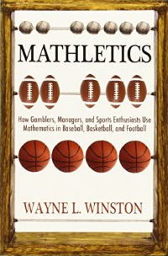 | Mathletics – Wayne L Winston | 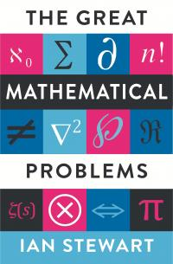 | The Great Mathematical Problems – Ian Stewart | 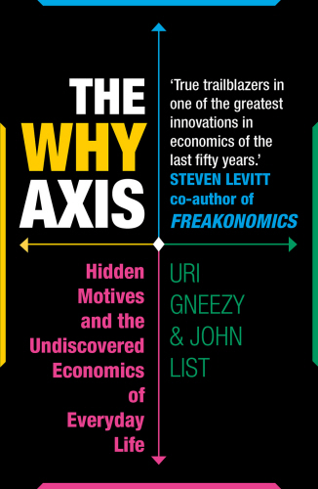 | The Why Axis – Steven Levitt

And some great websites too…

http://plus.maths.org/index.html  http://www.bbc.com/future | http://interestingengineering.com/  http://brilliant.org/ | http://chalkdustmagazine.com/

