A Dozen Great Mathematics Reading Books for Sixth-formers

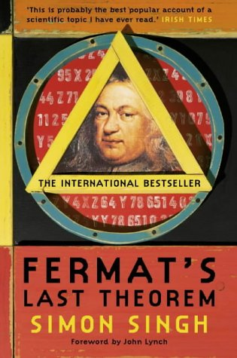 | Fermat’s Last Theorem - Simon Singh | 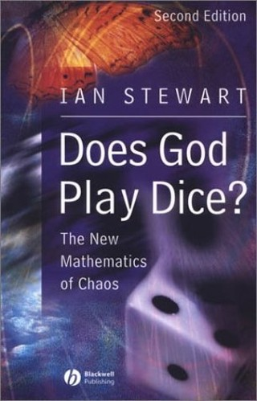 | Does God Play Dice - Ian Stewart | 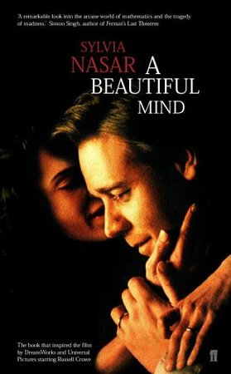 | A Beautiful Mind - Sylvia Nasar
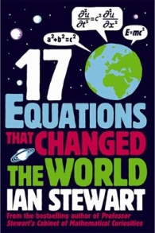 | 17 Equations that Changed the World – Ian Stewart | 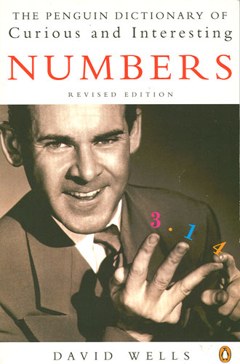 | The Penguin Book of Curious and Interesting Numbers - David Wells | 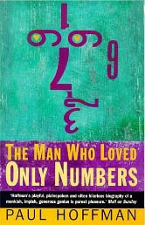 | The Man Who Loved Only Numbers – Paul Hoffman
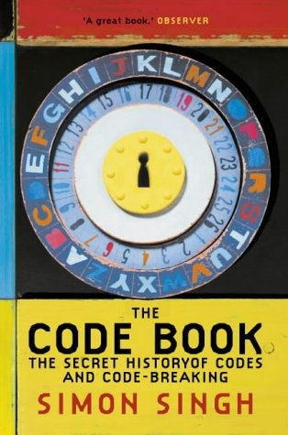 | The Code Book - Simon Singh | 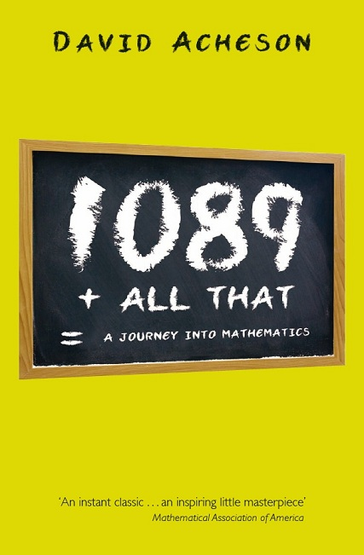 | 1089 And All That - David Acheson | 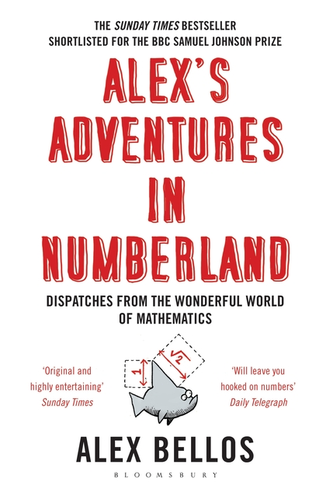 | Alex’s Adventures in Numberland – Alex Bellos
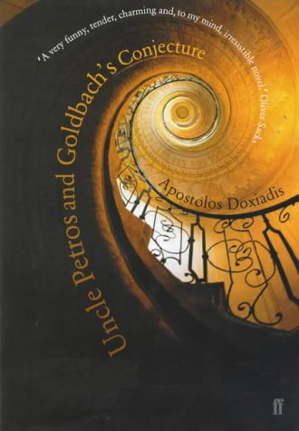 | Uncle Petros and Goldbach’s Conjecture - Apostolos Doxiadis | 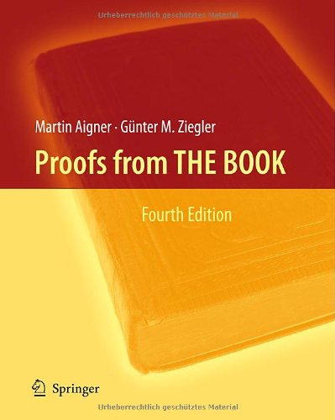 | Proofs from THE BOOK – Martin Aigner, Gunter M Ziegler | 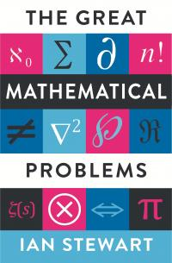 | The Great Mathematical Problems – Ian Stewart

