Great Questions in Maths

Find all real solutions of the equation

$${\left(x^{2}-5x+5\right)}^{\left(x^{2}-11x+30\right)}=1$$
$${\left(x^{2}-7x+11\right)}^{\left(x^{2}-13x+42\right)}=1$$
$${\left(x^{2}-7x+11\right)}^{\left(x^{2}-1\right)}=1$$

$$3^{444}+4^{333}$$

Multiple of 5?

Using ALL of
3, 3, 8, 8
and ANY of
$$× ÷+-$$

Make the number 24.

Evaluate the sum

$$\frac{1}{\sqrt{1}+\sqrt{2}}+\frac{1}{\sqrt{2}+\sqrt{3}}+\frac{1}{\sqrt{3}+\sqrt{4}}+…+\frac{1}{\sqrt{15}+\sqrt{16}}$$

A circle of radius 6cm is inscribed by a rectangle of perimeter 28cm. Find the area of the rectangle.

$$n^{2}+n+41$$

Is this a prime number for all natural numbers $n$?

$$p^{2}-1=24m$$

Take any prime number greater than 3, square it and subtract 1.
Is the answer a multiple of 24? Why is that?

$x^{1}, x^{3}, x^{4}, x^{2}, x^{0}$.

Five numbers are arranged in order from least to greatest as above. Where does ${-x}^{-1}$ belong in the list?

$x+\frac{1}{x}≥2$ where $x∈R, x>0$

True or false?
Solve
$$8^{x}=\frac{2^{56}-4^{26}}{30}$$

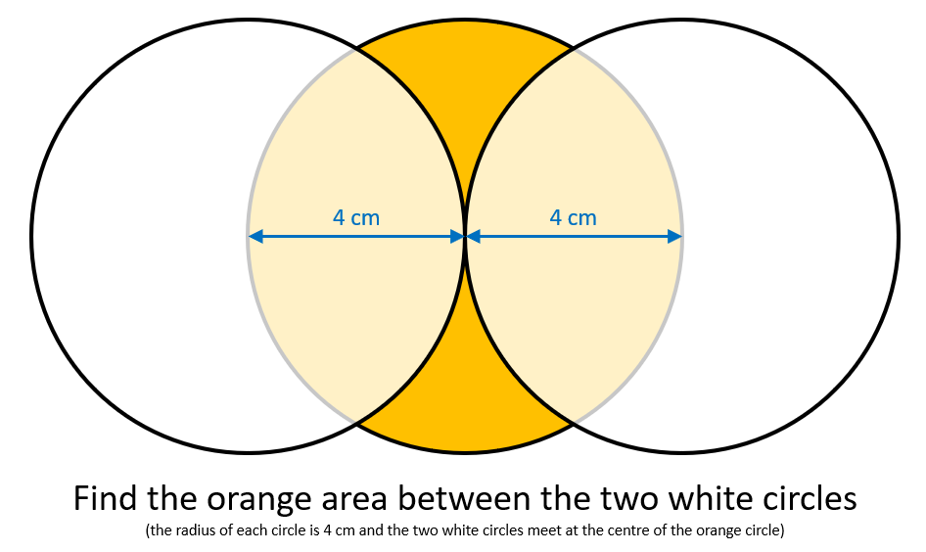

Sketch…

- $\left(sinx\right)\left(sin10x\right)$

- $sinx+0.1sin10x$

One day, Ant and Dec played several games of table tennis.

At five points during the day, Ant calculated the percentage of the games played so far that he had won. The results of these calculations were exactly 30%, exactly 40%, exactly 50%, exactly 60% and exactly 70% in this order.

What is the smallest possible number of games they played?

