Interesting Questions

Qu 1… Edexcel unit tests, Parametric Equations -Qu 3. (Link to markscheme)
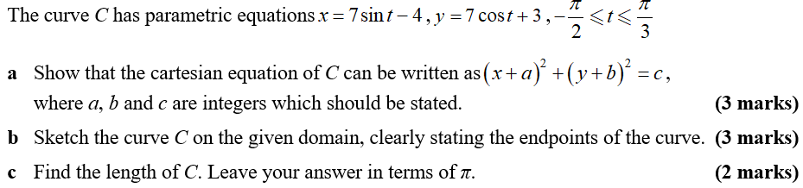

Qu 2… AQA A2 Paper 1, June 2018 -Qu 5. (Link to markscheme)
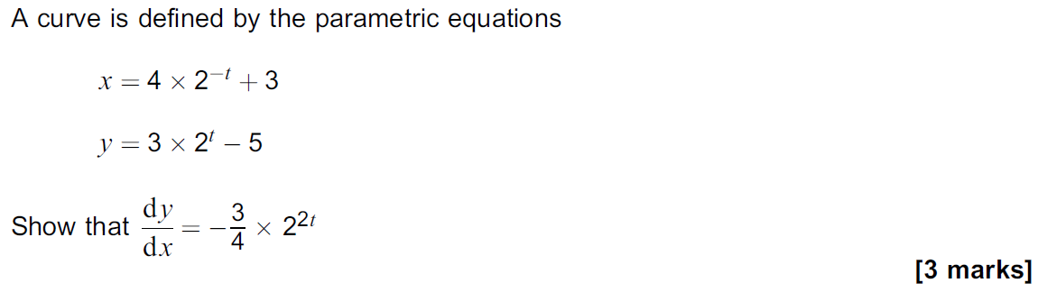
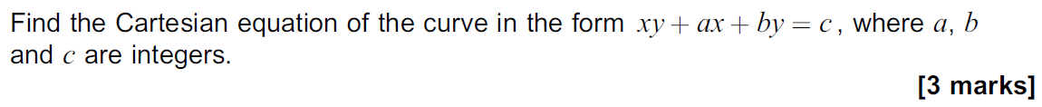

Qu 3… AQA A2 Paper 1, June 2018 – Qu 12. (Link to markscheme)
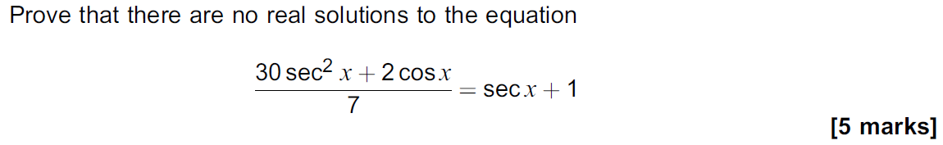

Qu 4… AQA A2 Paper 1, June 2018 – Qu13. (Link to markscheme)
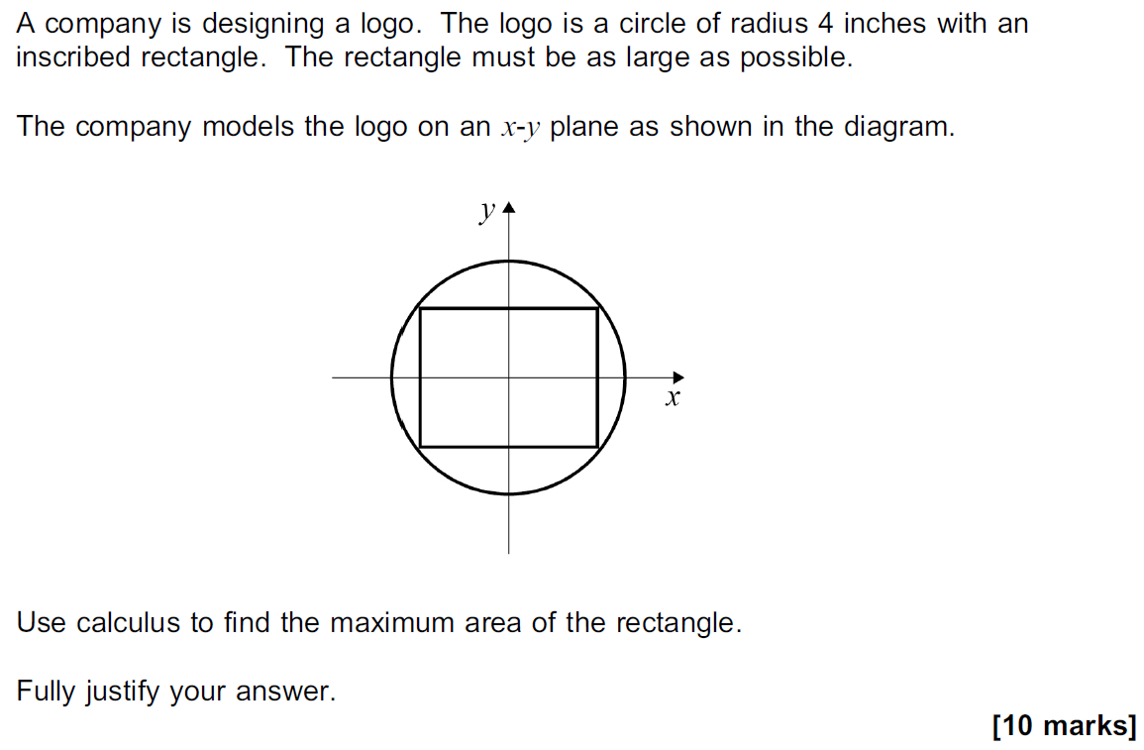

Qu 5… AQA A2 Paper 2, June 2018 -Qu 8. (Link to markscheme)
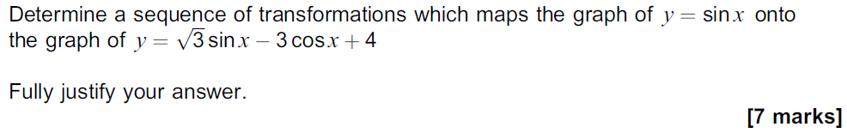
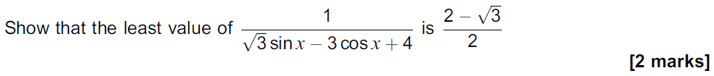
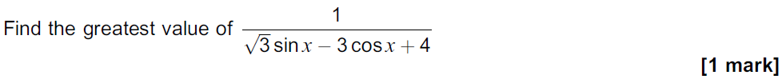

Qu 6… AQA A2 Paper 2, June 2018 - Qu 7. (Link to markscheme)

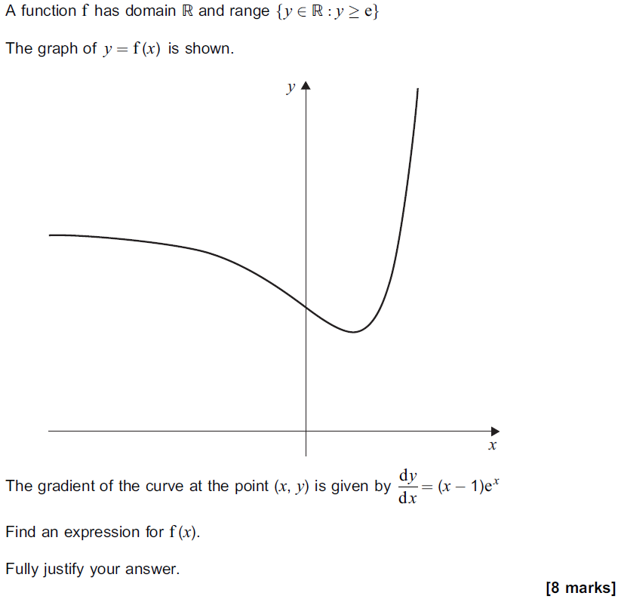

Qu 7… Edexcel unit tests, parametric Equations -Qu 6. (Link to markscheme)
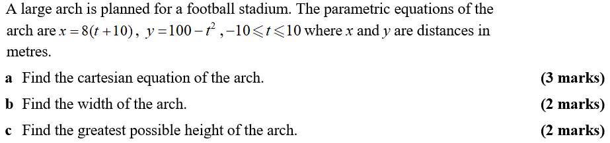

Qu 8… Edexcel Paper 1, June 2018 - Qu7. (Link to markscheme)
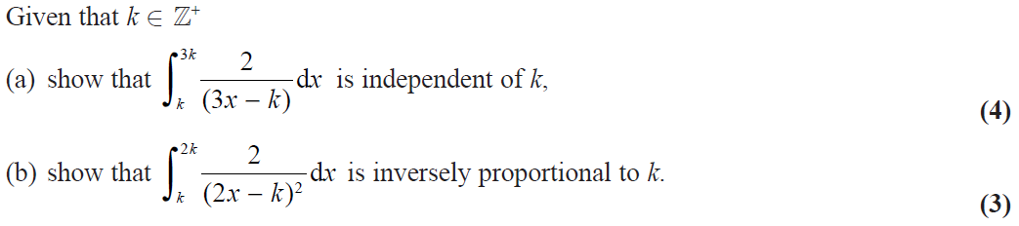

Qu 9… AQA Paper 3, June 2018 – Qu 6. (Link to markscheme)
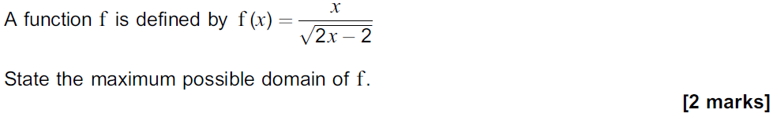

Qu 10… AQA Paper 3, June 2018 – Qu 8. (Link to markscheme)
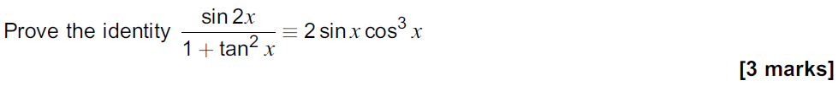

Qu 11… OCR A, Paper 2, June 2018. (Link to markscheme)

Qu 12… OCR A, Paper 2, June 2018. (Link to markscheme)
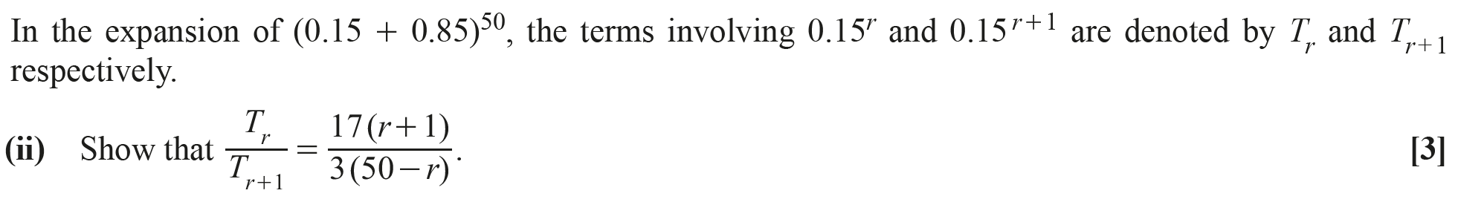

Qu 13… OCR, Paper 1, June 2018. (Link to markscheme)
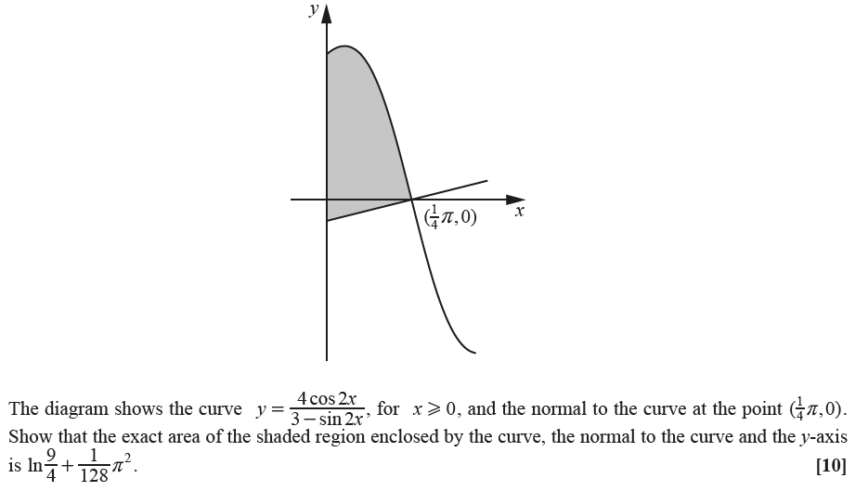

Qu 14… OCR, Paper 2, June 2018. (Link to markscheme)
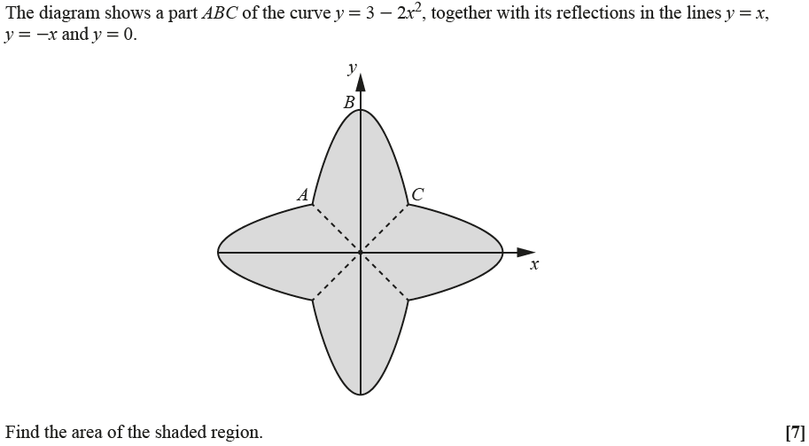

Qu 15… OCR Practice Papers, Set 2, Paper 3 - Qu3. (Link to markscheme)
What about $y=e^{3x-5}$ ?

Qu 16… OCR Practice Papers, Set 4, Paper 1. (Link to markscheme)

Qu 17… AQA Core 3, June 2013. (Link to markscheme)
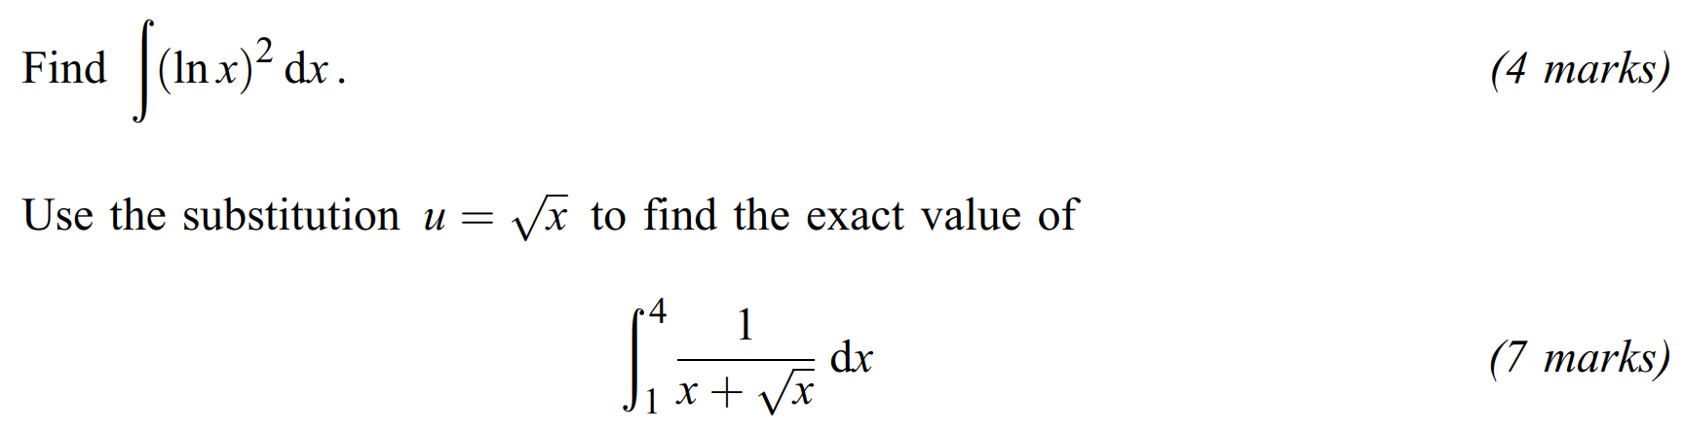

Qu 18… MEI, Paper 1, June 2018 – Qu 10. (Link to markscheme)
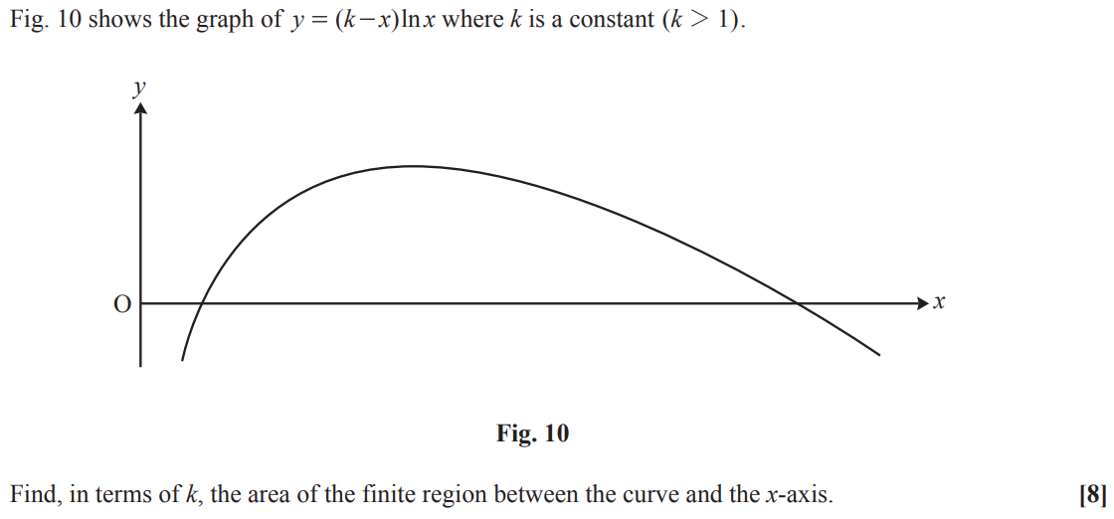

Qu 19… MEI, Paper 1, June 2018 -Qu 11. (Link to markscheme)
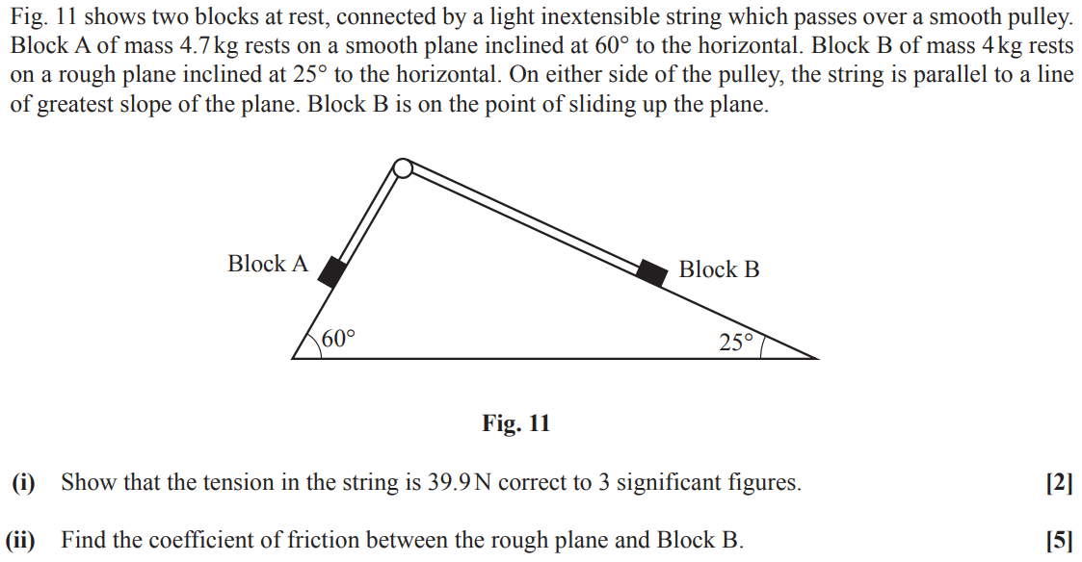

Qu 20… MEI, Paper 3, June 2018 – Qu 10. (Link to markscheme)
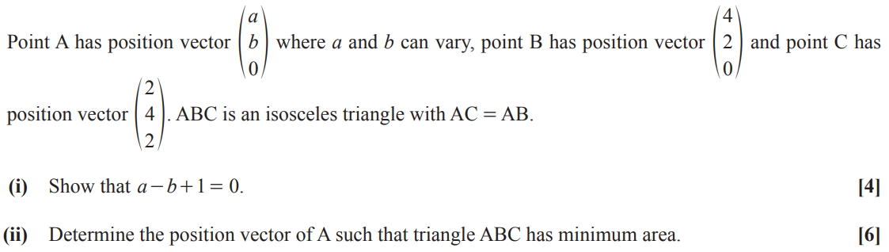

Qu 21… Edexcel Mock Papers, Paper 1 – Qu 11. (Link to markscheme)
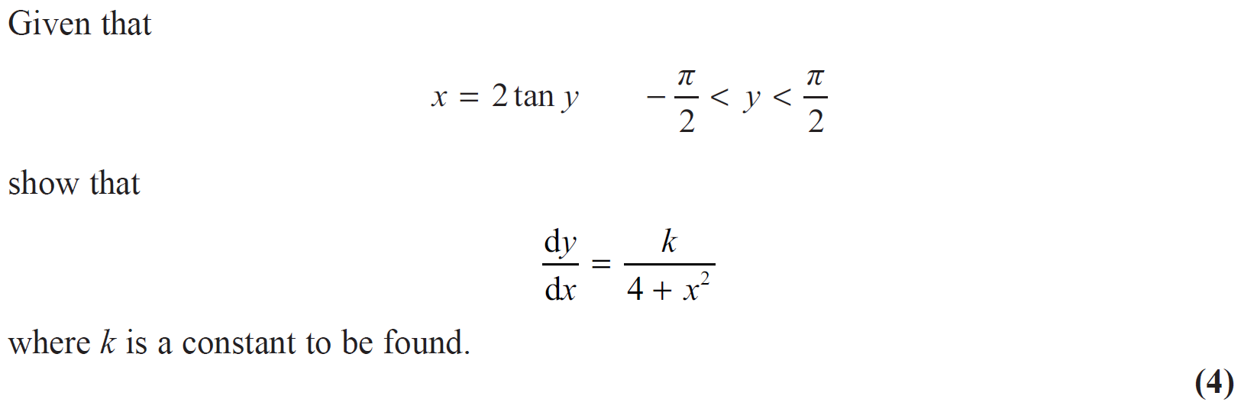

Qu 22… Edexcel Mock Papers, Paper 1 - Qu 10. (Link to markscheme)
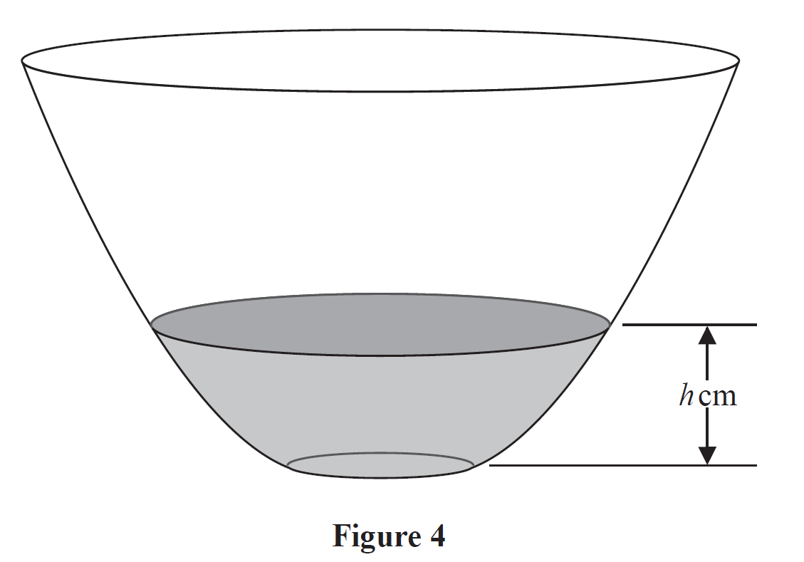
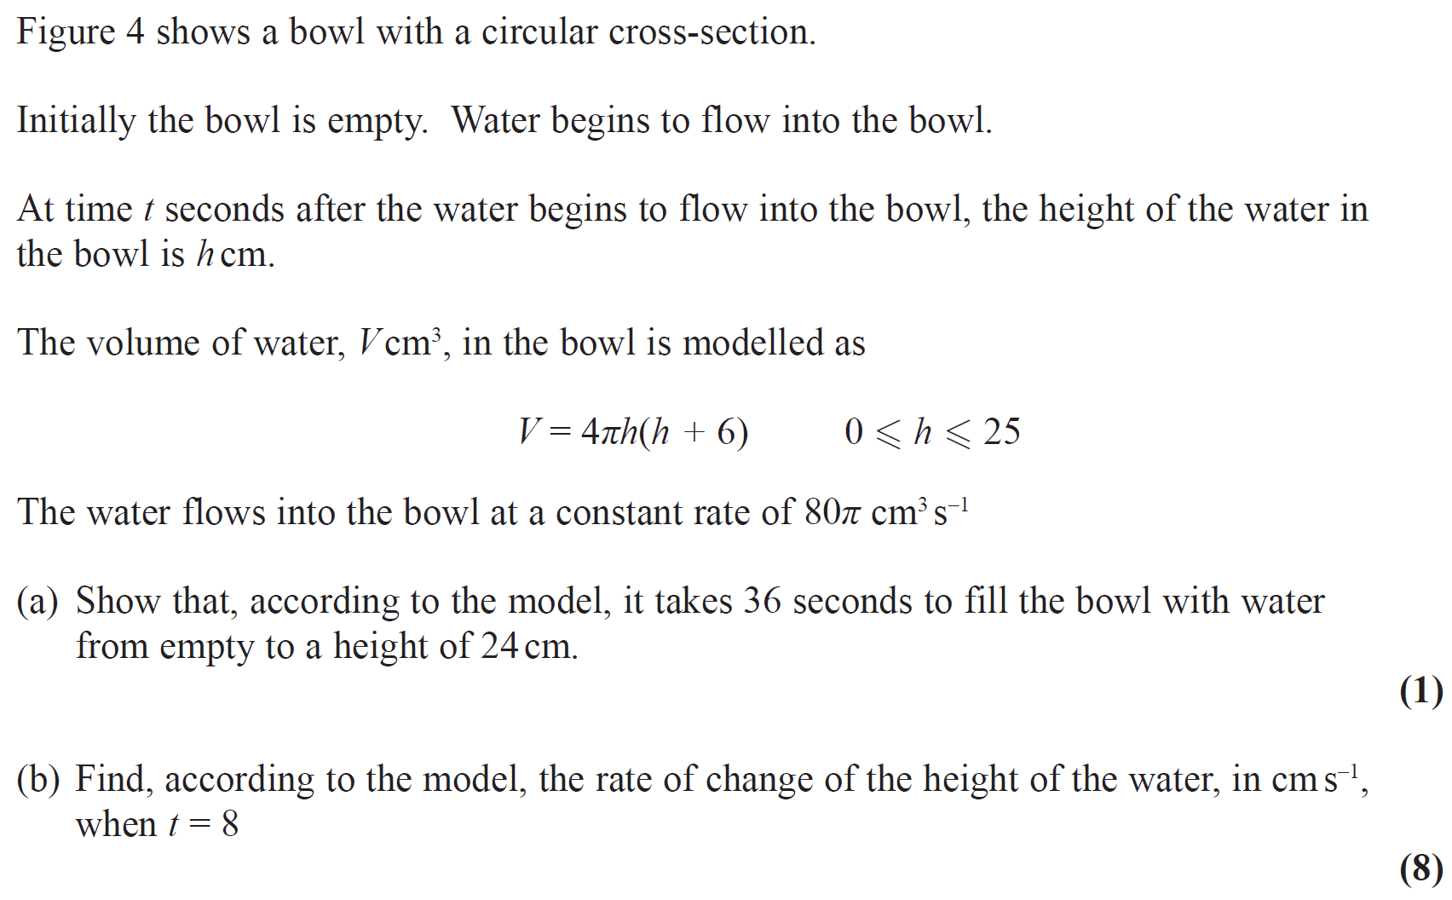

Qu 23… Edexcel, A2 Paper 1, June 2019 – Qu 9. (Link to markscheme)
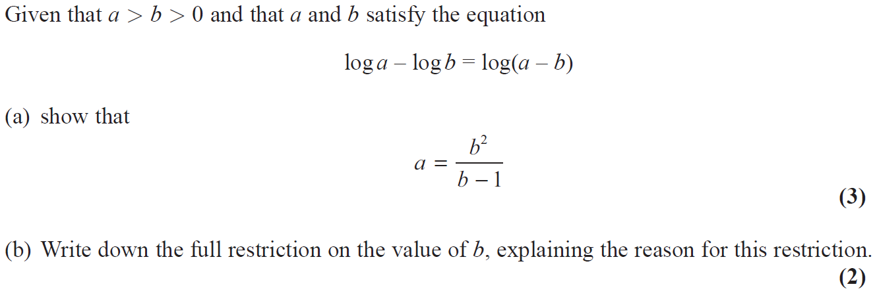
Qu 24… Edexcel Mock Papers, Paper 1 – Qu 13. (Link to markscheme)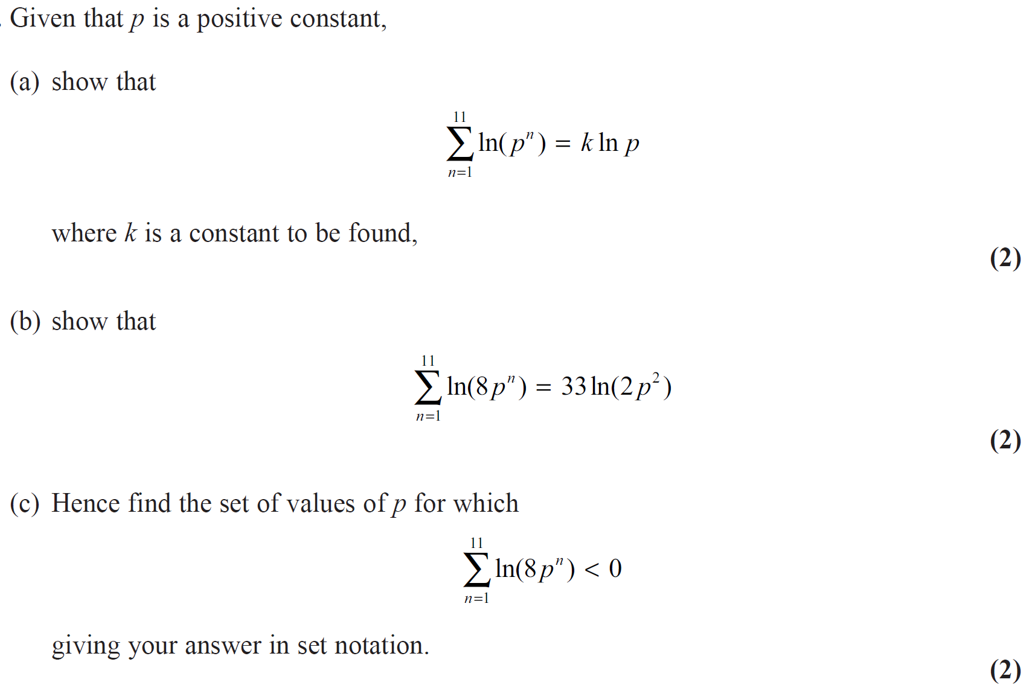

Qu 25… OCR AS Paper 2, 2019. (Link to markscheme)
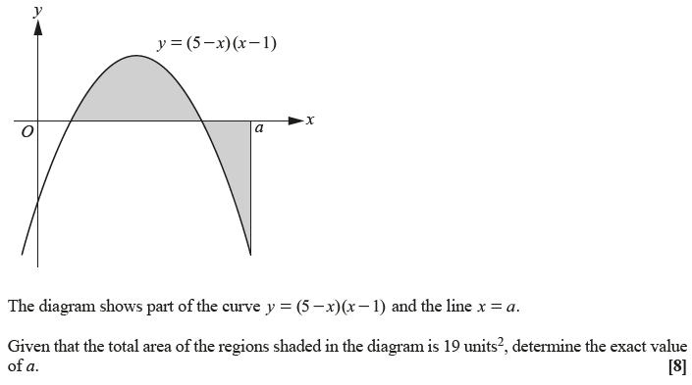

Qu 26… Edexcel Mock Papers, Paper 1 -Qu 14. (Link to markscheme)
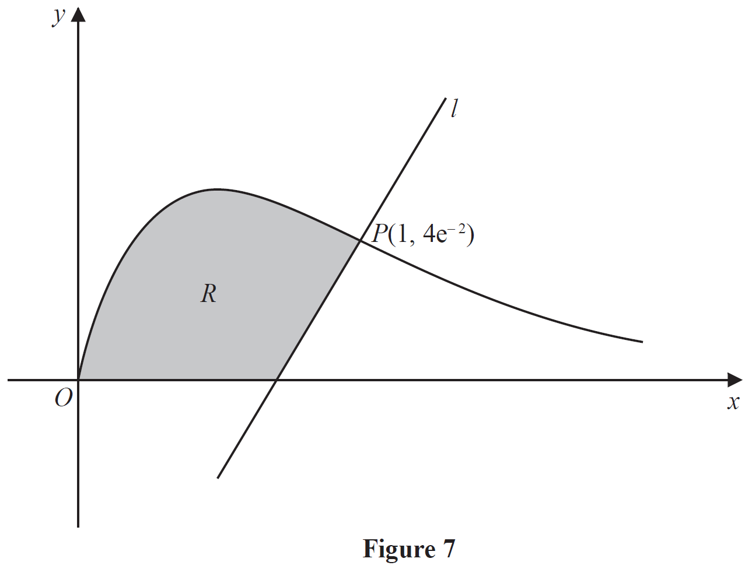
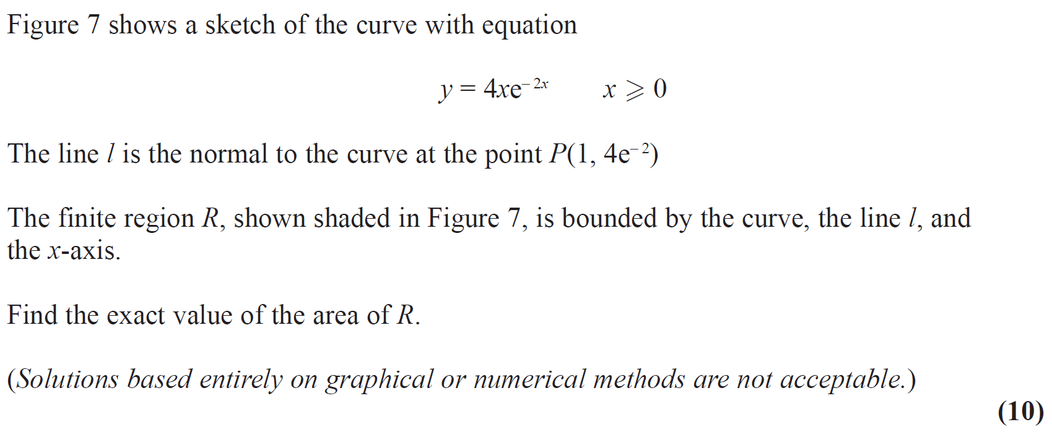

Qu 27… Edexcel A2 Paper 2, 2018 – Qu 4. (Link to markscheme)
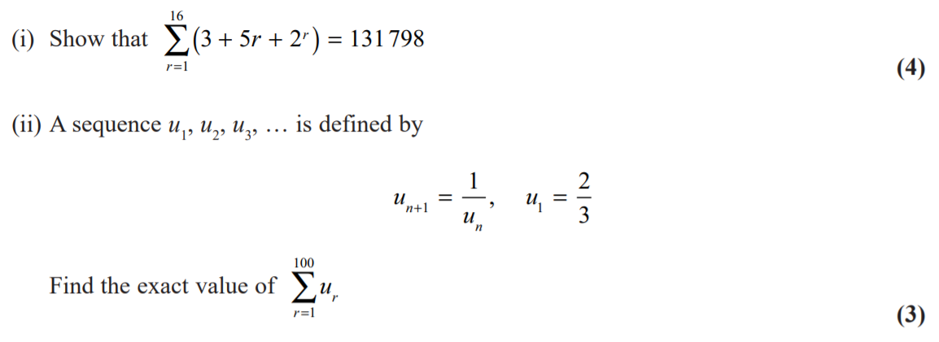

Qu 28… AQA, A2 Paper 2, 2019. (Link to markscheme)
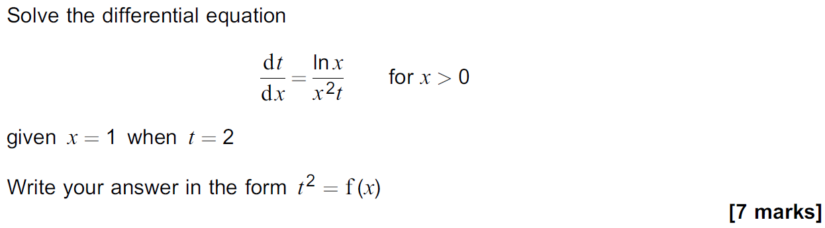

Qu 29… Edexcel, A2 Paper 1, June 2019 – Qu 5. (Link to markscheme)

Qu 30… Edexcel unit tests, Integration – Qu 8. (Link to markscheme)
Use the substitution $x=4\sin^{2}θ$ to find

,

giving your answer in the form $aπ+b$, where $a$ and $b$ are exact constants.
(9)

Qu 31… Edexcel, A2 Paper 1, June 2019 – Qu 4. (Link to markscheme)
The binomial expansion of
$$\frac{1}{\sqrt{4-x}}$$

Can be used to find an approximation to $\sqrt{2}$.

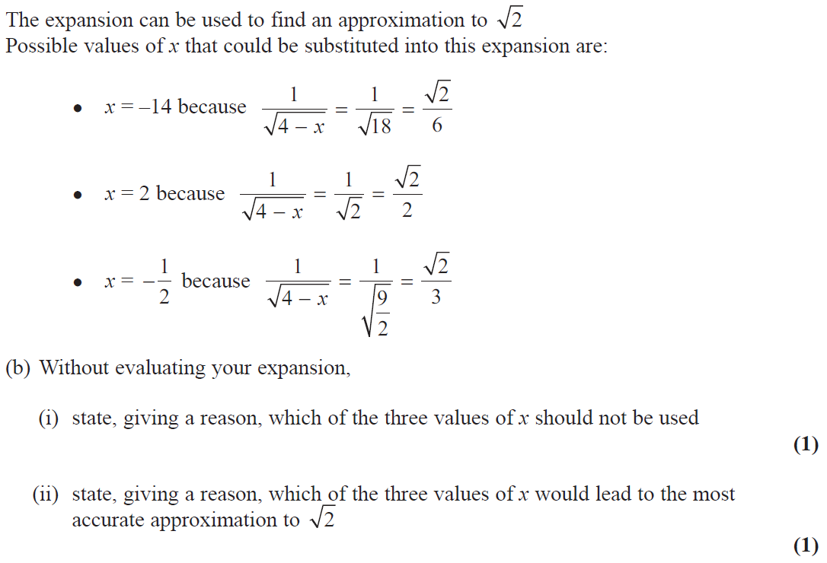

Qu 32… Edexcel, A2 Paper 1, June 2019 – Qu 14. (Link to markscheme)

Qu 33… AQA, A2 Paper 2, 2019. (Link to markscheme)
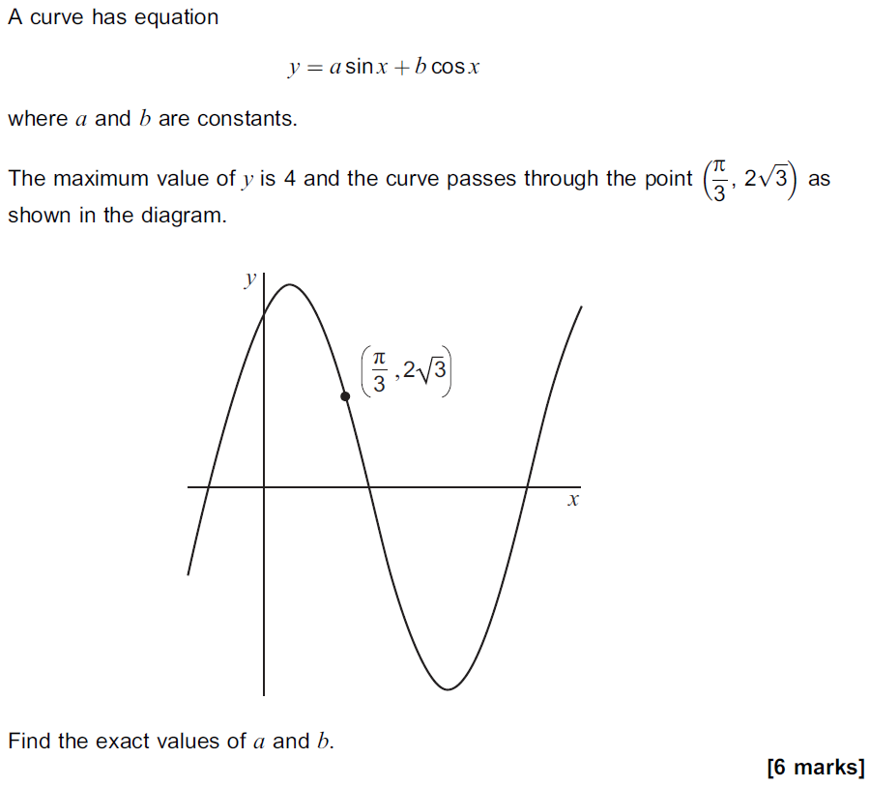

Qu 34… Edexcel Unit Tests, A2 Stats, Topic 2, Hypothesis Testing. (Link to markscheme)
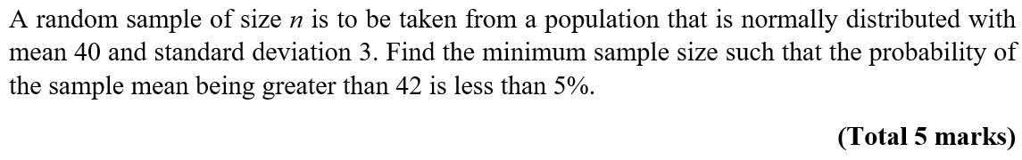

Qu 35… OCR A Core 3 June 2013, Differentiation. (Link to markscheme)
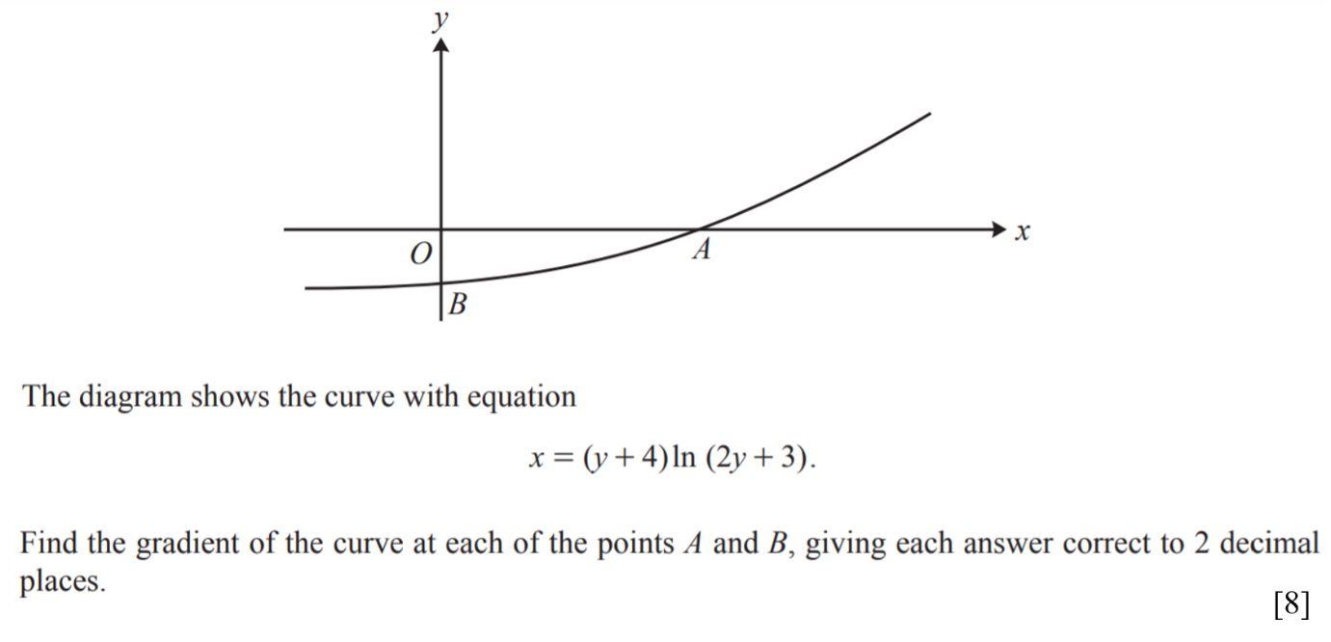

Qu 36… OCR A Practice Papers Set 1, Paper 3, Question 6. (Link to markscheme)
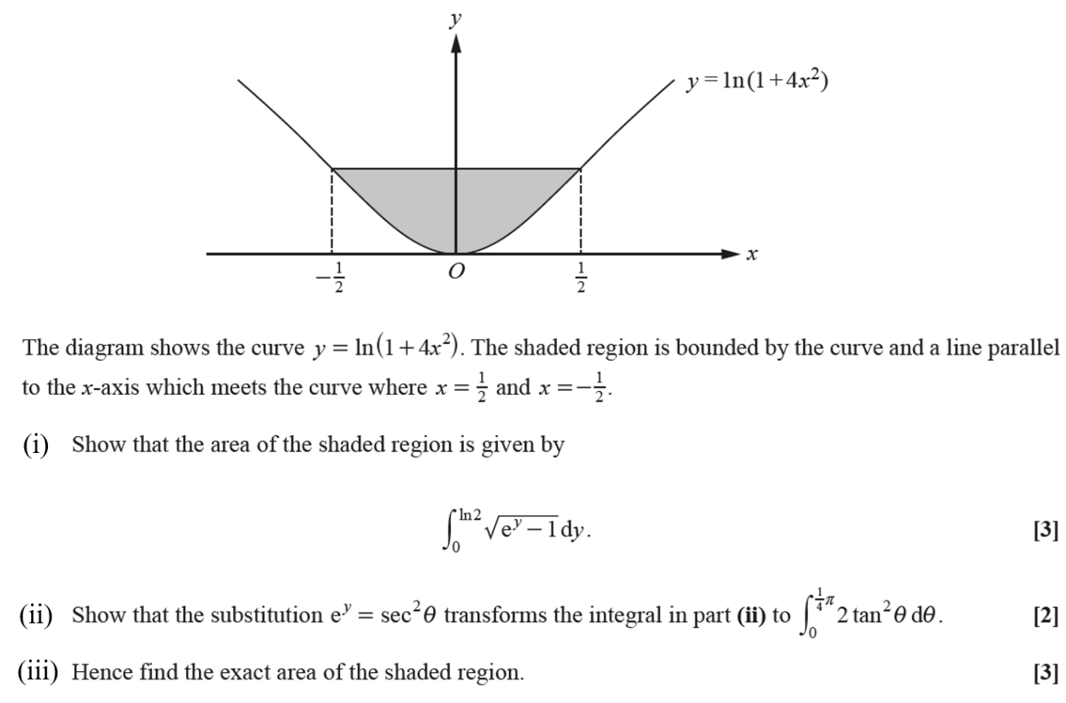

Qu 37… OCR A Practice Papers Set 4, Paper 3, Question 10. (Link to markscheme)
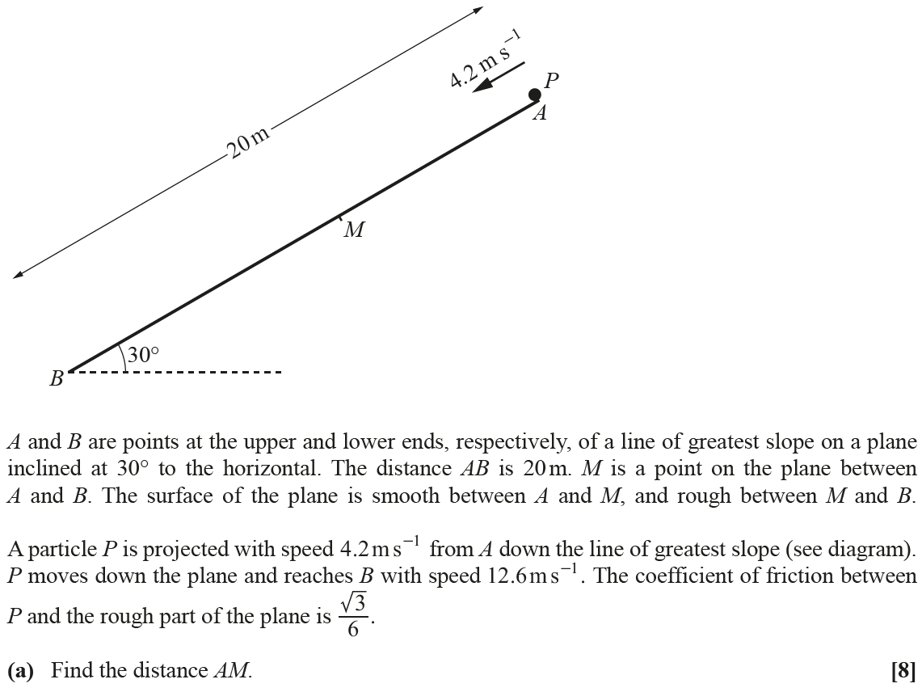

Qu 38… OCR A Practice Papers Set 2, Paper 2, Question 6. (Link to markscheme)
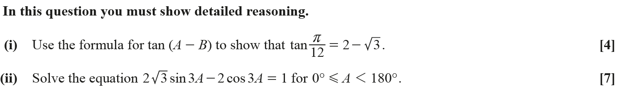

Qu 39… OCR A Practice Papers Set 2, Paper 3, Question 5. (Link to markscheme)
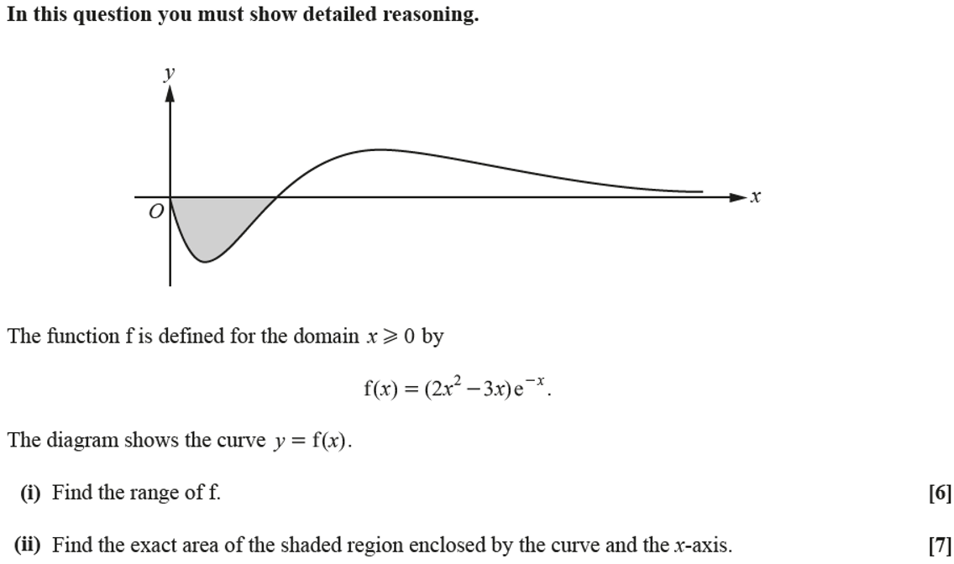

Qu 40… OCR A Sample Assessment Paper, Maths & Statistics, Question 12. (Link to markscheme)
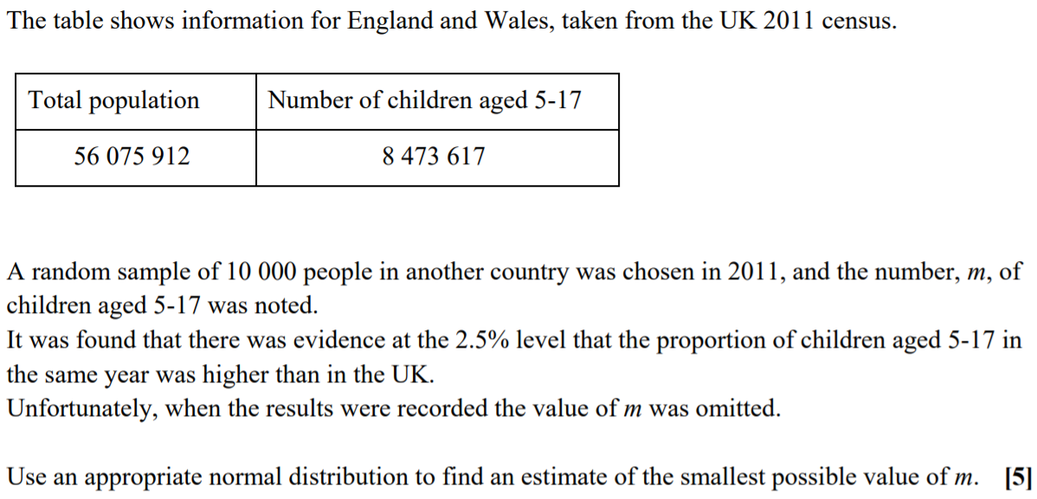

Qu 41… OCR, A2 Paper 2, 2018, Question 5 (Link to markscheme)

Qu 43… OCR Practice Papers, Set 1, Paper 1, Question 12. (Link to markscheme)
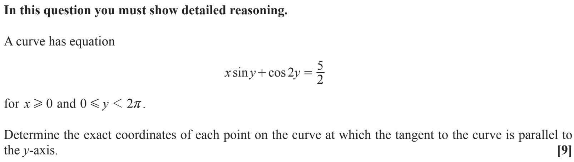

Qu 43… OCR, A2 Paper 3, 2019, Question 6 (Link to markscheme)
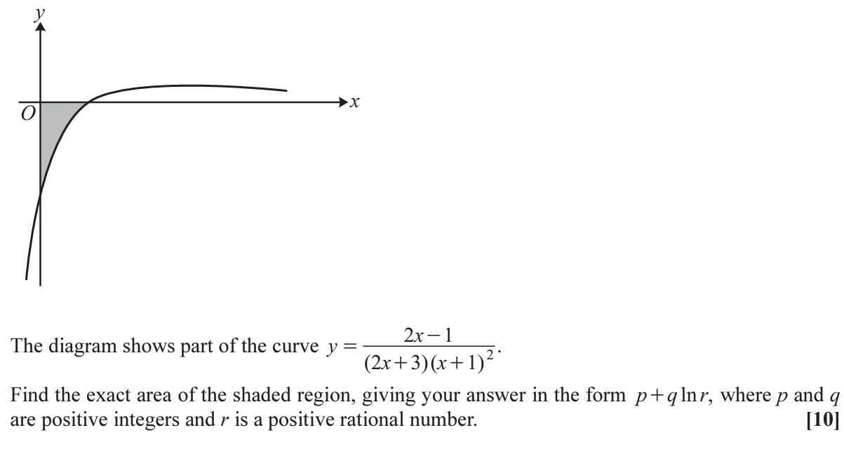

Qu 44… OCR Practice papers Set 2, Paper 2, Question 7 (Link to markscheme)

Qu 45… OCR A2 Paper 1, 2019, Question 2 (link to markscheme)
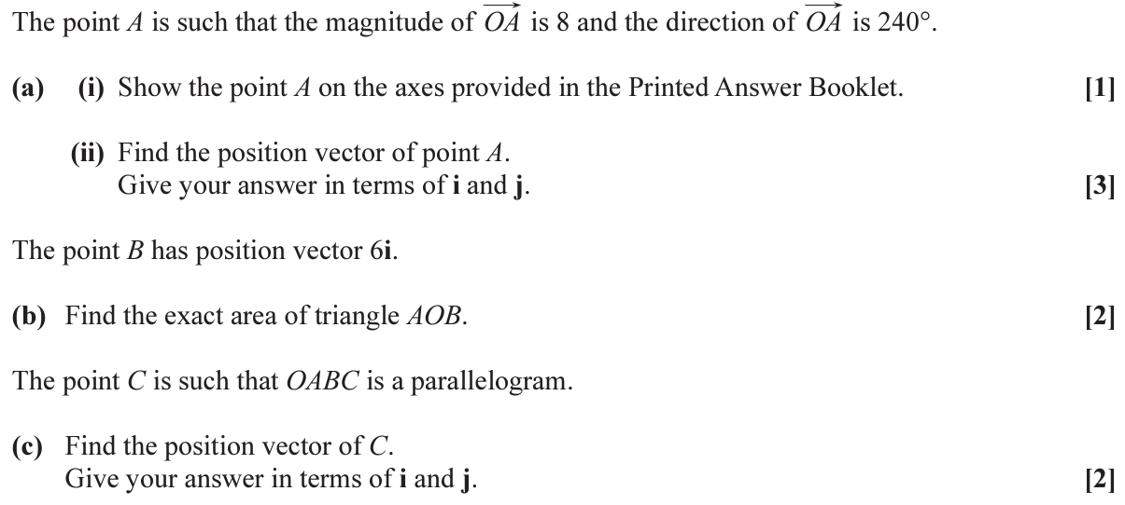

Qu 46… OCR A2 Paper 2, 2019, Question 9 (link to markscheme)
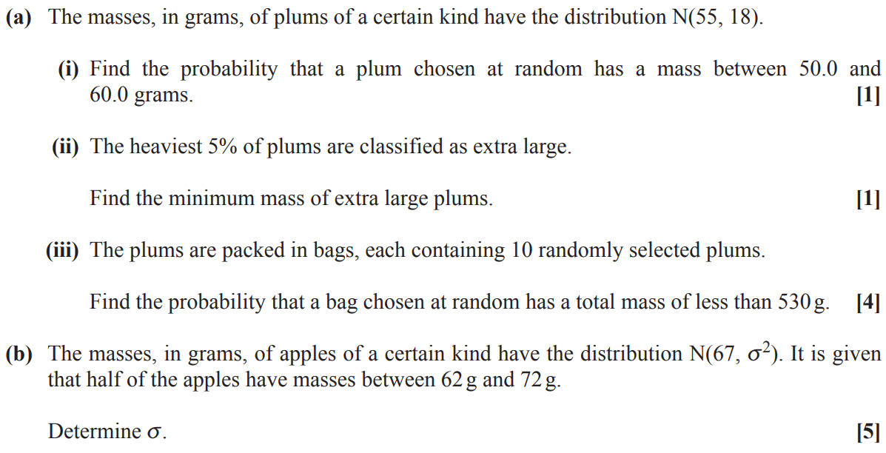

Qu 47… AQA Level 2 Certificate in Further Maths, Paper 2, 2017, Question 24 (Link to markscheme)

Qu 48… OCR A2 Paper 2, 2020, Question 3 (Link to markscheme)
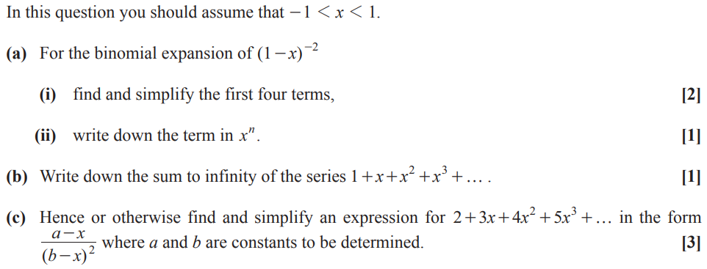

Qu 49… OCR A2 Paper 1, 2021, Question 11 (Link to markscheme)
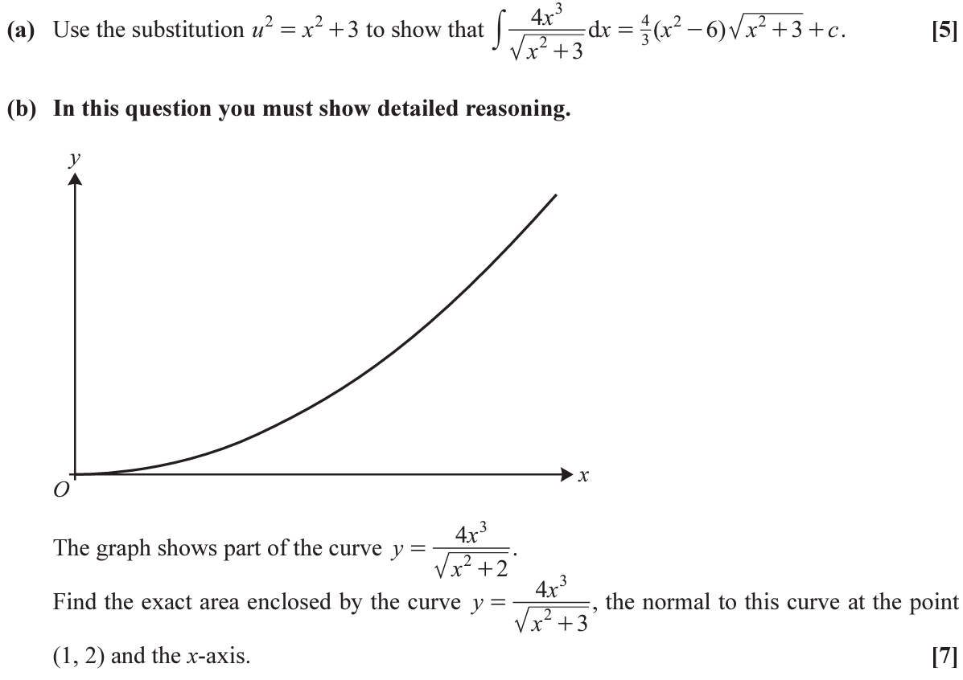
3

Qu 50… Edexcel Specimen Paper 3, Question 3 (Link to markscheme)
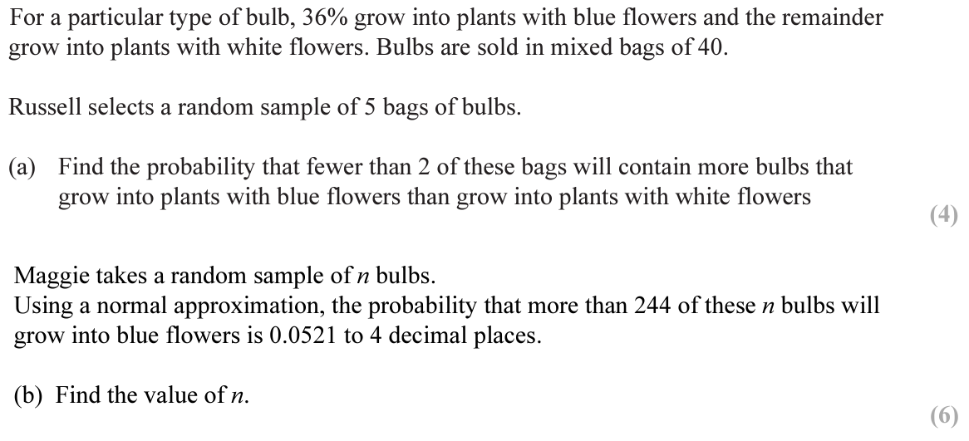

Qu 51… OCR A2 Paper 1, 2021, Question 7 (Link to markscheme)
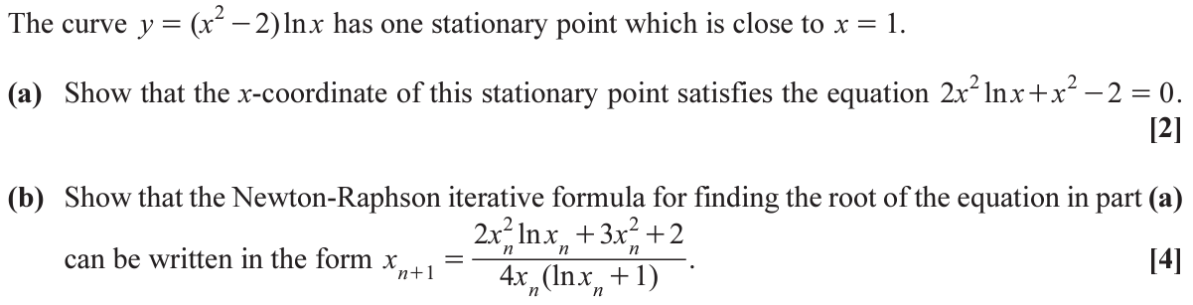

Qu 52… OCR A2 Paper 1, 2019, Question 7 (Link to markscheme)
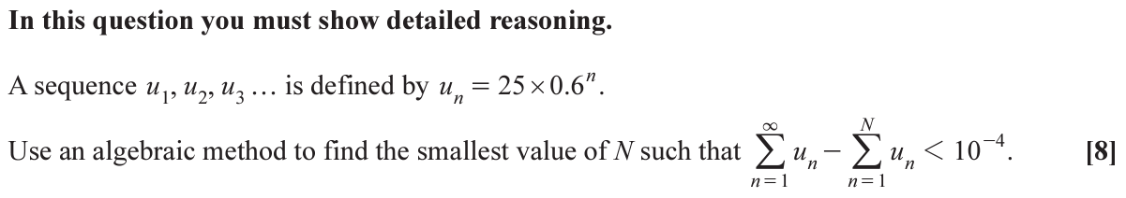

Qu 53… OCR A2 Paper 2, 2021, Question 5 (Link to markscheme)
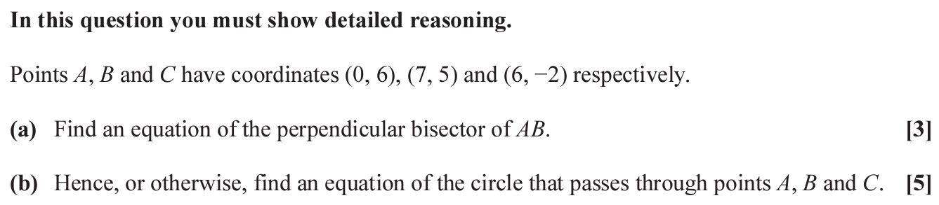

Qu 54… OCR A2 Paper 1, 2019, Question 12 (Link to markscheme)
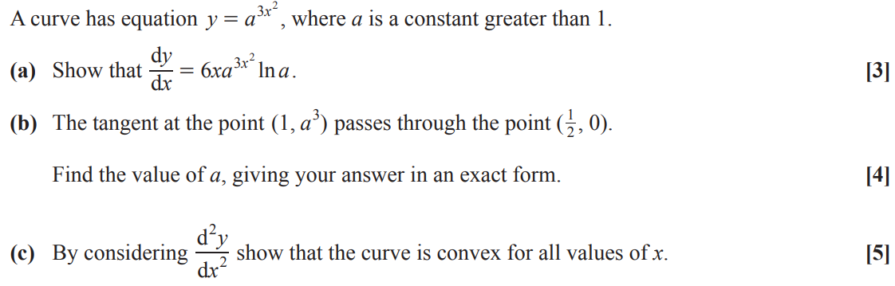

Qu 55… OCR A2 Paper 2, 2020, Question 15 (Link to markscheme)
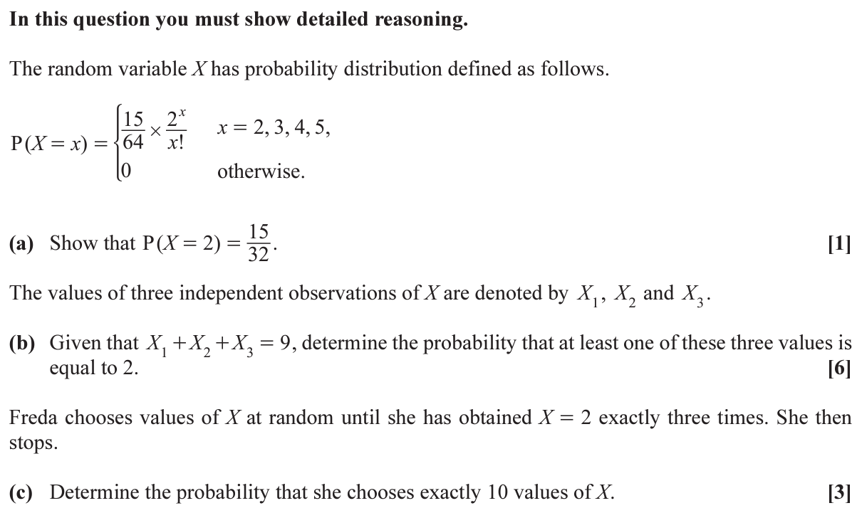

Qu 56… OCR A2 Paper 2, 2020, Question 7 (Link to markscheme)
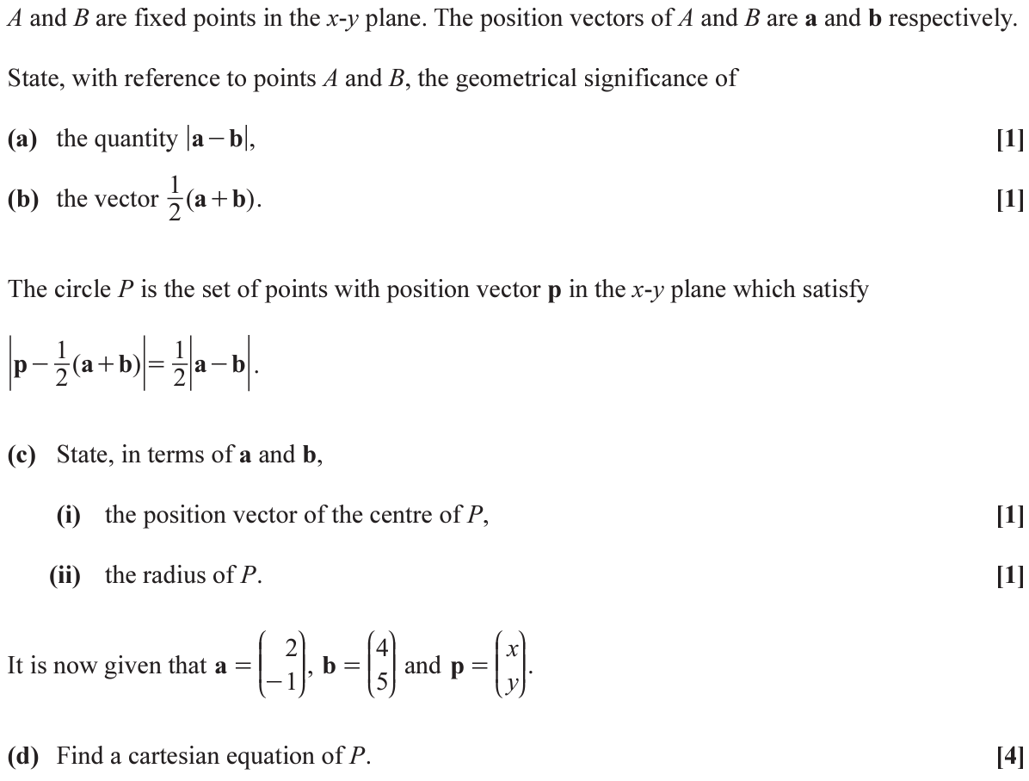

Qu 57… Edexcel Mock Set 4, Paper 2, Question 10 (Link to markscheme)
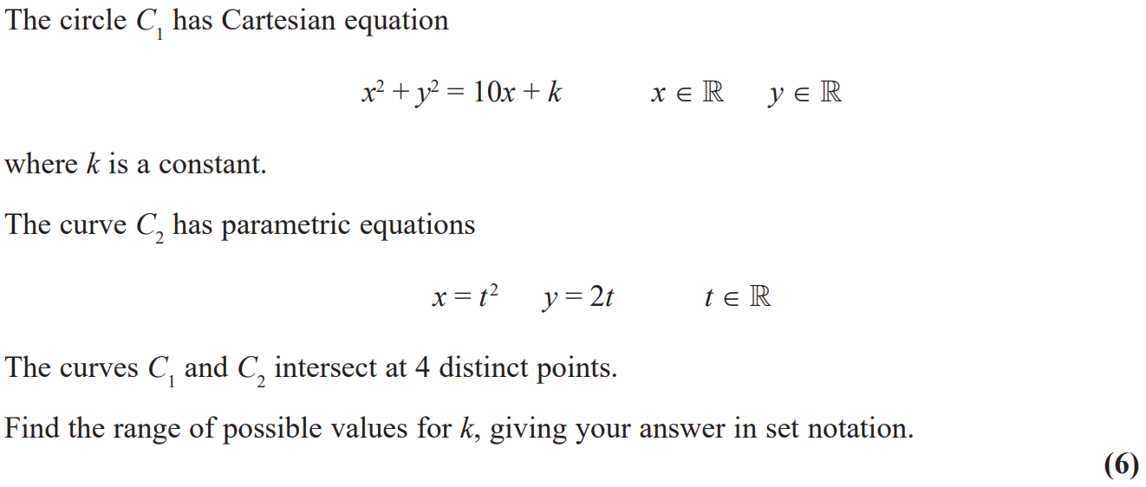

Qu 58… MEI Practice Papers Set 4, Paper 2, Question 12 (Link to markscheme)
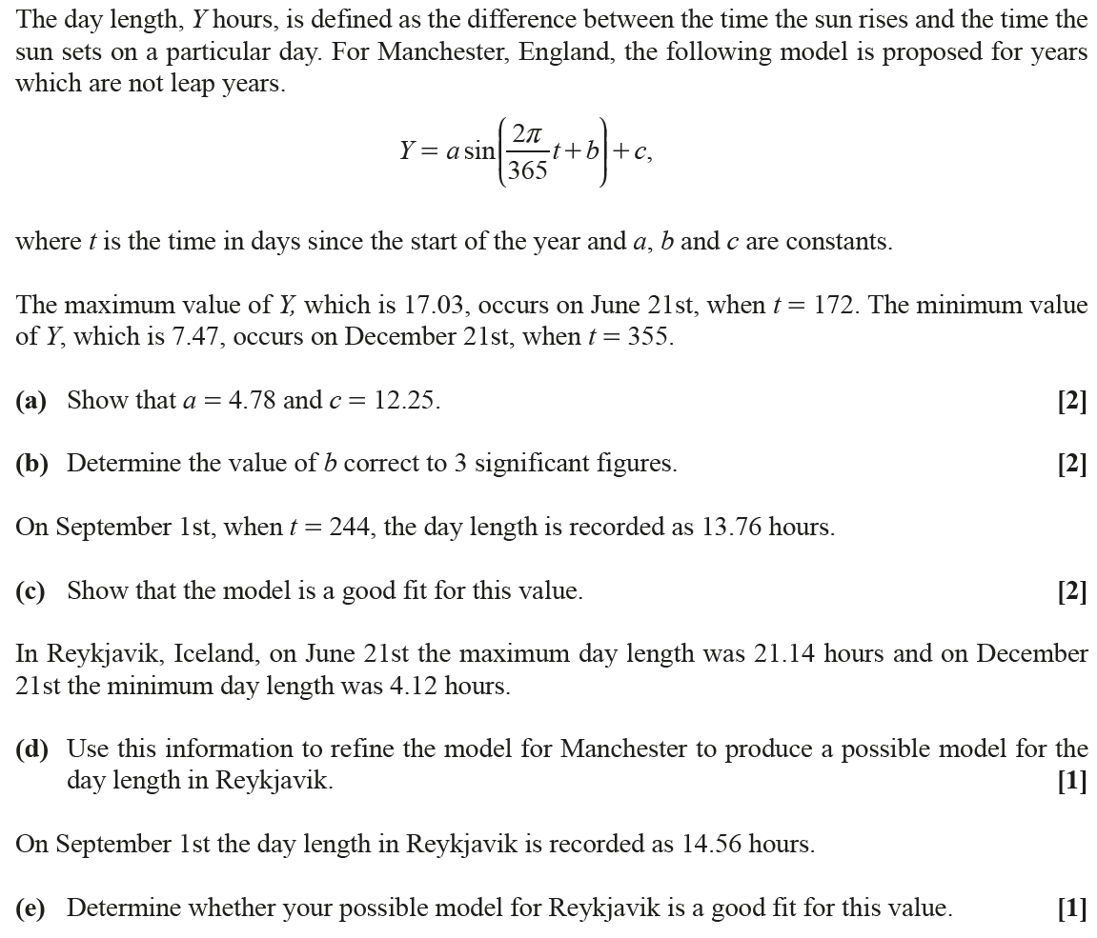

Qu 59… OCR Practice Papers Set 4, Paper 2, Question 6 (Link to markscheme)
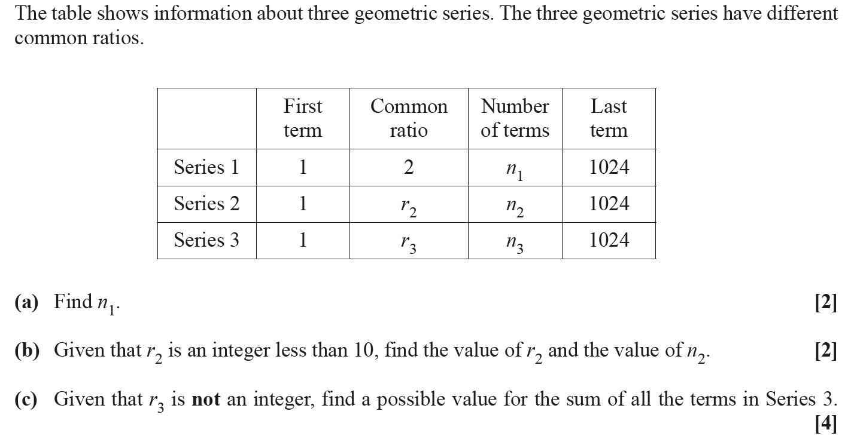

Qu 60… Edexcel Mock Papers Set 2 (2020), Paper 2, Question 14 (Link to markscheme)
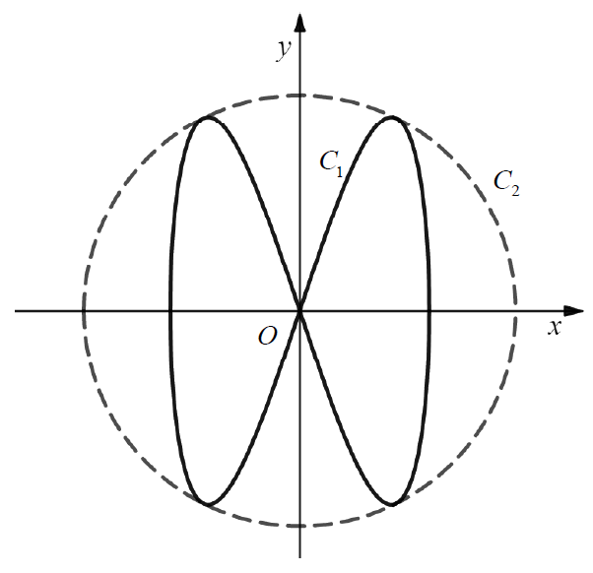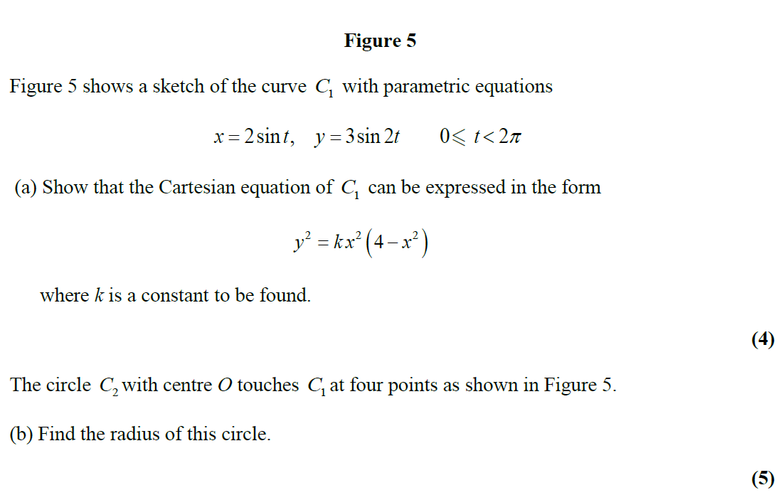

Qu 61… adapted from Edexcel Core 3 June 2012, Question 7b (Link to markscheme)
Given that $x=3tan2y$ find $\frac{dy}{dx}$ in terms of $x$ without involving any trigonometrical functions.

Qu 62… adapted from Edexcel Sample Paper 2 June 2012, Question 8 (Link to markscheme)
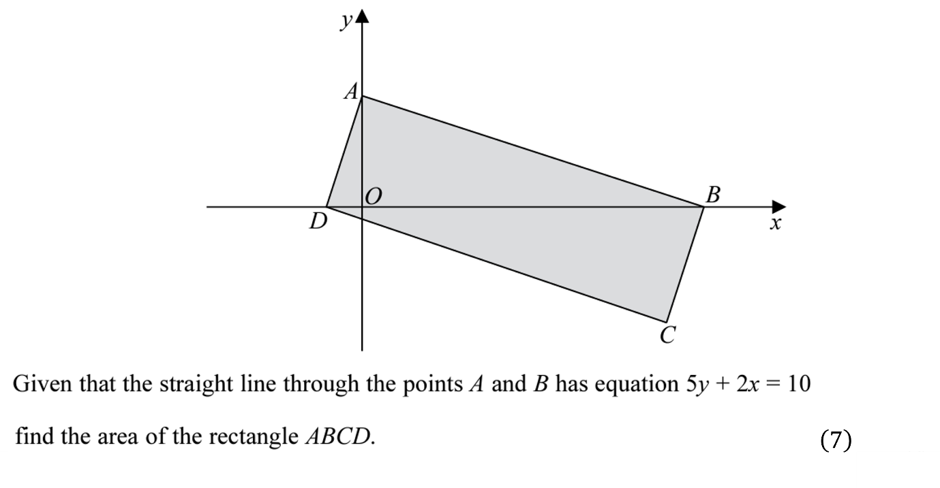

Qu 63… OCR A2 Paper 1 June 2020 - Question 9 (Link to markscheme)
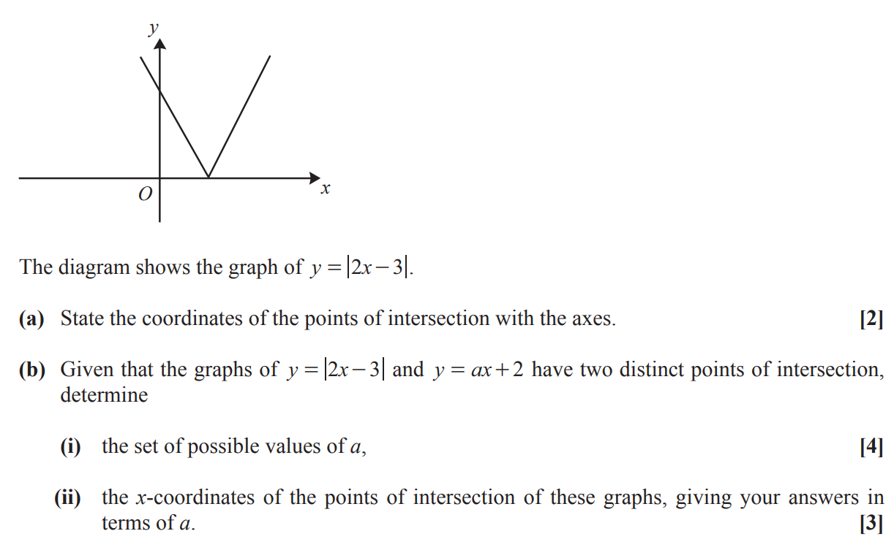

Qu 64… OCR A2 Paper 1 June 2020 - Question 9 (Link to markscheme)
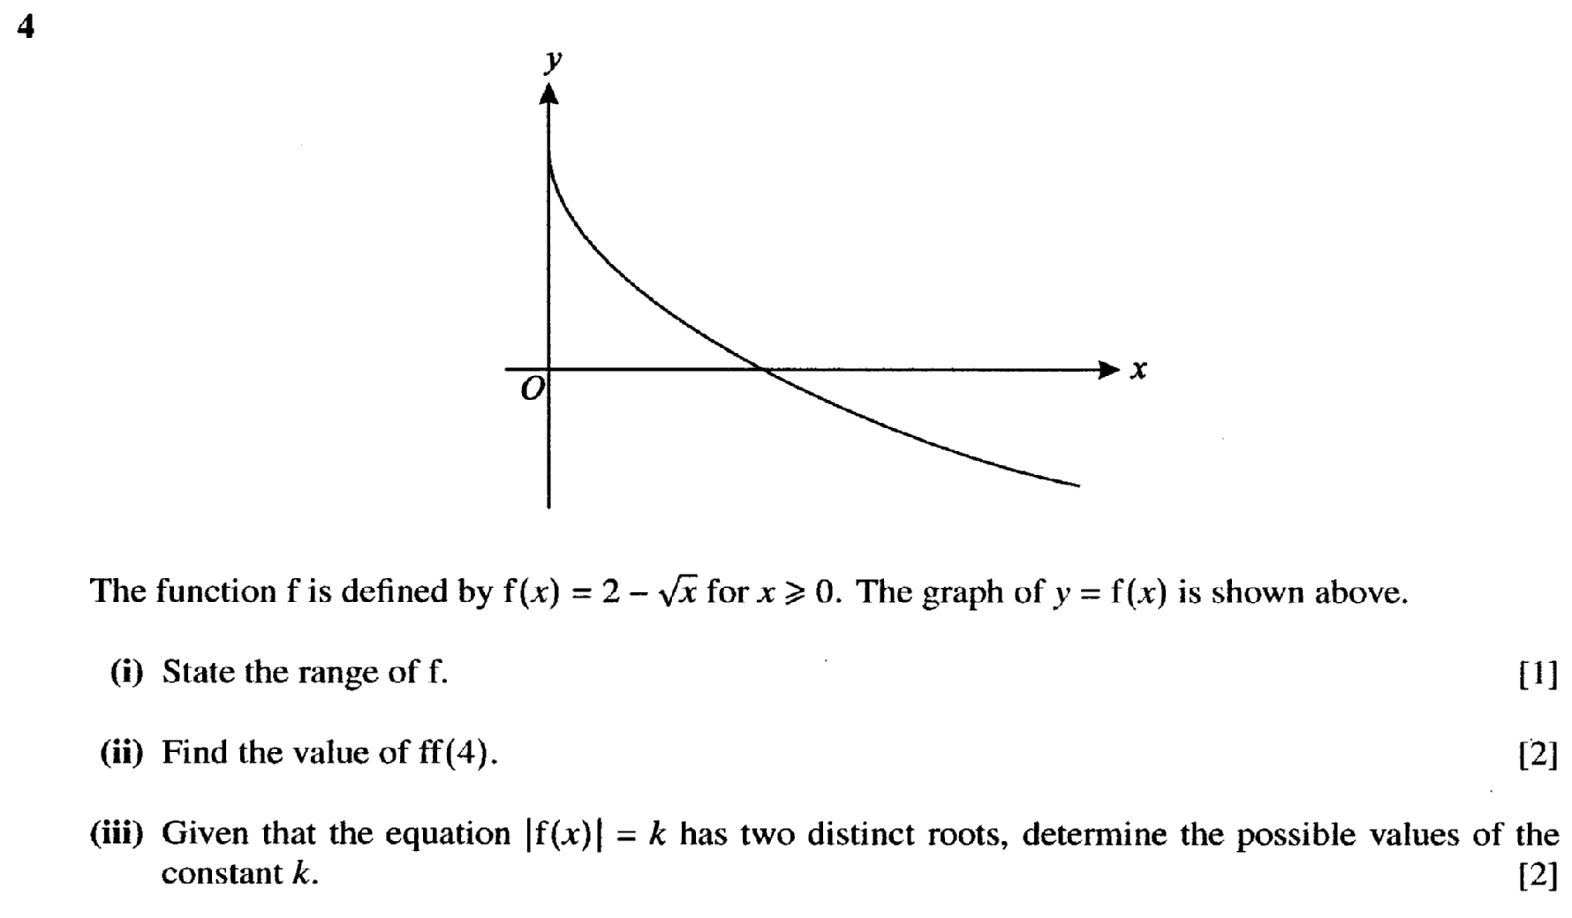

Qu 65… Edexcel A2 Paper 3 Statistics June 2021 - Question 6 (Link to markscheme)
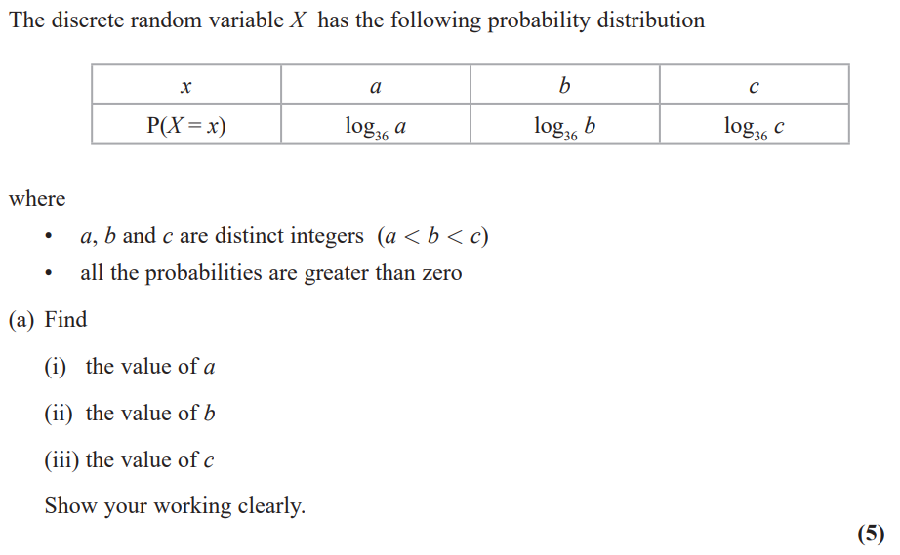

Qu 66… OCR AS Paper 2 June 2023 - Question 8 (Link to markscheme)
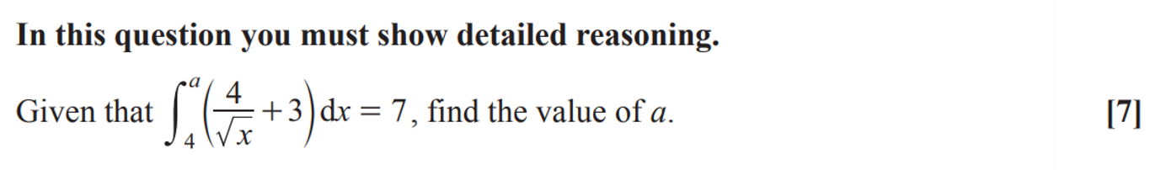

Qu 67… OCR A2 Paper 1 June 2022 - Question 12 (Link to markscheme)
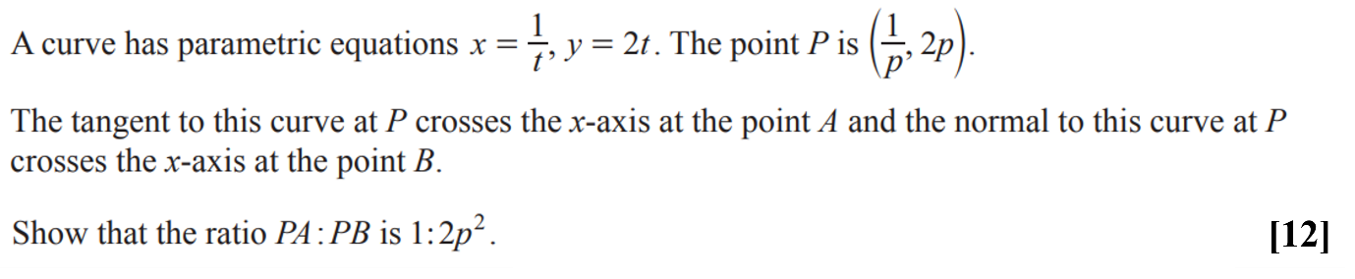

Qu 68… OCR A2 Paper 2 June 2022 - Question 8 (Link to markscheme)
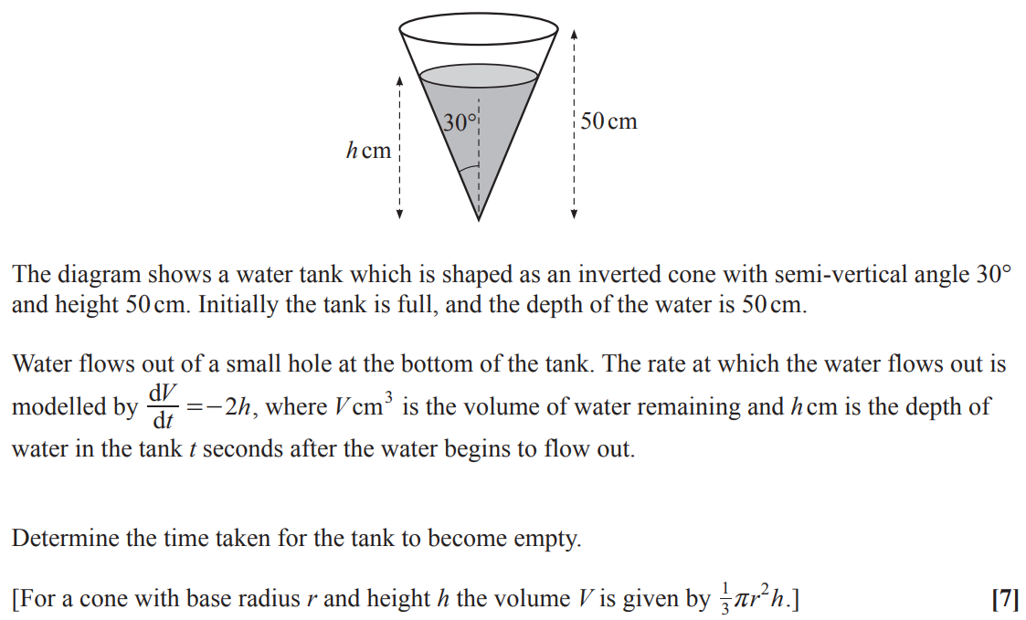

Qu 69… MEI A2 Paper 2 June 2023 - Question 17 (Link to markscheme)
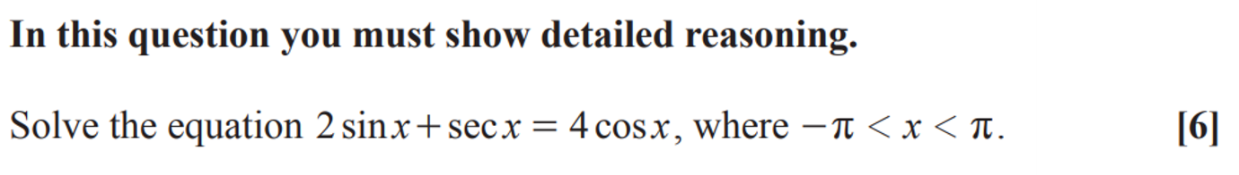

Interesting Questions - Answers

Qu 1… Edexcel unit tests, Parametric Equations - Qu 3. (Link back to question)
$$\frac{35}{6}π$$

Qu 2… AQA A2 Paper 1, June 2018 -Qu 5. (Link back to question)
$$xy+5x-3y=27$$

Qu 3… AQA A2 Paper 1, June 2018 – Qu 12. (Link back to question)
$$(2x+1)(5x-2)(3x-1)$$

Qu 4… AQA A2 Paper 1, June 2018 – Qu13. (Link back to question)
32 sq in

Qu 5… AQA A2 Paper 2, June 2018 -Qu 8. (Link back to question)

Qu 6… AQA A2 Paper 2, June 2018 - Qu 7. (Link back to question)

Qu 7… Edexcel unit tests, parametric Equations -Qu 6. (Link back to question)
Width = 160m
Height = 100m

Qu 8… Edexcel Paper 1, June 2018 - Qu7. (Link back to question)
-

Qu 9… AQA Paper 3, June 2018 – Qu 6. (Link back to question)

Qu 10… AQA Paper 3, June 2018 – Qu 8. (Link back to question)

Qu 11… OCR A, Paper 2, June 2018. (Link back to question)
0.0668 or 0.067

Qu 12… OCR A, Paper 2, June 2018. (Link back to question)
-

Qu 13… OCR, Paper 1, June 2018. (Link back to question)
-

Qu 14… OCR, Paper 2, June 2018. (Link back to question)
$$\frac{44}{3}$$

Qu 15… OCR Practice Papers, Set 2, Paper 3 - Qu3. (Link back to question)

Qu 16… OCR Practice Papers, Set 4, Paper 1. (Link back to question)
$$(ln7, ln2)$$

Qu 17… AQA Core 3, June 2013. (Link back to question)

Qu 18… MEI, Paper 1, June 2018 – Qu 10. (Link back to question)

Qu 19… MEI, Paper 1, June 2018 -Qu 11. (Link back to question)
$$μ=0.656$$

Qu 20… MEI, Paper 3, June 2018 – Qu 10. (Link back to question)

Qu 21… Edexcel Mock Papers, Paper 1 – Qu 11. (Link back to question)

Qu22… Edexcel Mock Papers, Paper 1 - Qu 10. (Link back to question)

Qu 23… Edexcel, A2 Paper 1, June 2019 – Qu 9. (Link back to question)

Qu 24… Edexcel Mock Papers, Paper 1 – Qu 13. (Link back to question)
$$66lnp$$

Qu 25… OCR AS Paper 2, 2019 – Qu7. (Link back to question)

Qu 26… Edexcel Mock Papers, Paper 1 -Qu 14. (Link back to question)
or

Qu 27… Edexcel A2 Paper 2, 2018 – Qu 4. (Link back to question)

Qu 28… AQA, A2 Paper 2, 2019. (Link back to question)

Qu 29… Edexcel, A2 Paper 1, June 2019 – Qu 5. (Link back to question)
Qu 30… Edexcel unit tests, Integration – Qu 8. (Link back to question)

Qu 31… Edexcel, A2 Paper 1, June 2019 – Qu 4. (Link back to question)

Qu 32… AQA, A2 Paper 2, 2019. (Link back to question)

Qu 33… Edexcel, A2 Paper 1, June 2019 – Qu 14. (Link back to question)
$$a=2, b=2\sqrt{3}$$

Qu 34… Edexcel Unit Tests, A2 Stats, Topic 2, Hypothesis Testing. (Link to question)
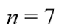

Qu 35… OCR A Core 3 June 2013, Differentiation. (Link to question)
, 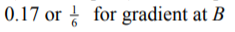

Qu 36… OCR A Practice Papers Set 1, Paper 3, Question 6. (Link to question)

Qu 37… OCR A Practice Papers Set 4, Paper 3, Question 10. (Link to question)

Qu 38… OCR A Practice Papers Set 2, Paper 2, Question 6. (Link to question)
- (“Show that”)
- A = 14.8, 65.2, 134.8

Qu 39… OCR A Practice Papers Set 2, Paper 2, Question 6. (Link to question)
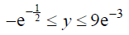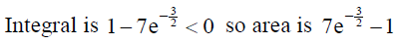

Qu 40… OCR A Sample Assessment Paper, Maths & Statistics, Question 12. (Link to question)

Qu 41… OCR, A2 Paper 2, 2018, Question 5. (Link to question)
Start with $n^{2}-853=m^{2}$ then use difference of two squares and 853 is prime to obtain
$n+m=853$ and $n-m=1$

Qu 42… OCR Practice Papers, Set 1, Paper 1, Question 12. (Link to question)
$\left(\frac{7}{2},\frac{π}{2}\right), \left(2\sqrt{3},\frac{π}{3}\right), \left(2\sqrt{3},\frac{2π}{3}\right)$ but be sure to discount $siny=-\frac{\sqrt{3}}{2}$ as $x<0$ isn’t allowed

Qu 43… OCR 2019, Paper 3, Question 6. (Link to question)
Area $=1+8ln⁡(\frac{8}{9})$

Qu44… OCR Practice papers Set 2, Paper 2, Question 7 (Link to question)
Time when depth is 2 cm, and vol is 200cm3, is 11.0 seconds (10.9861)

Qu 45… OCR A2 Paper 1, 2019, Question 12 (Link to question)
a i) Length 8, angle 240 measured anti-clockwise from +ve x axis.
a ii) $-4i-4\sqrt{3}j$
b) $12\sqrt{3}$
c) $10i+4\sqrt{3}j$

Qu 46… OCR A2 Paper 2, 2019, Question 9 (Link to question)
a i) $0.761, 0.762$ or $0.76$
a ii) $62(.0)$
a iii) $0.068(0)$
b) $σ=7.41$or $σ=7.42$

Ans 47… AQA Level 2 Certificate in Further Maths, Paper 2, 2017, Question 24 (Link to question)
$$3{\left(2x-5\right)}^{2}-70$$
i.e. $a=3, b=2, c=-5, d=70$

Ans 48… OCR A2 Paper 2, 2020, Question 3 (Link to question)

Ans 49… OCR A2 Paper 1, 2021, Question 11 (Link to question)
Area under curve = $\frac{4}{3}\left(6\sqrt{3}-10\right)=0.523$
Area under triangle = 11
Total area = $8\sqrt{3}-\frac{7}{3}=11.523$

Ans 50… Edexcel Paper 3, 2022, Question 3 (Link to question)
a)
b)

Ans 51… OCR A2 Paper 1, 2021, Question 7 (Link to question)
(Both parts of the question are show that)

Ans 52… OCR A2 Paper 1, 2019, Question 7 (Link to question)
$N>25.125$ i.e. $N=26$

Ans 53… OCR A2 Paper 2, 2021, Question 5 (Link to question)
- $y=7x-19$
- ${\left(x-3\right)}^{2}+{\left(y-2\right)}^{2}=25$

Ans 54… OCR A2 Paper 1, 2019, Question 12 (Link to question)
b) $a=e^{\frac{1}{3}}$
c) $\frac{d^{2}y}{dx^{2}}=2e^{x^{2}}+4x^{2}e^{x^{2}}$ or $\frac{d^{2}y}{dx^{2}}=a^{3x^{2}}\left(6lna\right)\left(1+6x^{2}lna\right)$, then show why this is always positive

Ans 55… OCR A2 Paper 2, 2020, Question 15 (Link to question)
- “Show that”
- 0.854 or $\frac{117}{137}$
- 0.0433

Ans 56… OCR A2 Paper 2, 2020, Question 7 (Link to question)
- Length of AB
- Midpoint of AB
- i) $\frac{1}{2}\left(a+b\right)$, ii) $\frac{1}{2}\left|a-b\right|$
- ${\left(x-3\right)}^{2}+{\left(y-2\right)}^{2}=10$

Ans 57… Edexcel Mock Set 4, Paper 2, Question 10 (Link to question)
$-9<k<0$, or in set notation
$$\left\{k:k<0\right\}∩\left\{k:k>-9\right\}$$

Ans 58… Edexcel Mock Set 4, Paper 2, Question 10 (Link to question)
- $a=4.78$ and $c=12.25$
- $b=-1.39$
- Use $t=244$ and then $Y=13.81$, which is fairly close to $13.75$
- $a=8.51$ and $c=12.63$
- New model is not a good fit as it gives 15.40 hrs

Ans 59… Edexcel Mock Set 4, Paper 2, Question 10 (Link to question)
- $n_{1}=11$
- $r_{2}=4$
$n_{2}=6$
- $r_{3}=\sqrt{2}$ (or any other power of $\sqrt{2}$). Using $\sqrt{2}$ gives $n_{3}=21$
$S_{21}=2047+1023\sqrt{2}$ (or 2490).
Other versions of $r_{3}$ based on $\sqrt[n]{2}$ work here

Ans 60… Edexcel Mock Papers Set 2 (2020), Paper 2, Question 14 (Link to question)
- $y^{2}=\frac{9}{4}x^{2}\left(4-x^{2}\right)$

- $r=\frac{10}{3}$

Ans 61… adapted from Edexcel Core 3 June 2012, Question 7b (Link to question)
$$\frac{dy}{dx}=\frac{3}{18+2x^{2}}$$

Ans 62… adapted from Edexcel Sample Paper 2 June 2012, Question 8 (Link to question)
Area $ABCD=11.6$

Qu 63… OCR A2 Paper 1 June 2020 - Question 9 (Link to Question)
- $-\frac{4}{3}<a<2$
- $x=\frac{1}{2+a}$

Qu 64… A great question from a long time ago (Link to Question)
- $f(x)≤2$
- $ff\left(4\right)=2$
- $0<k≤2$

Qu 65… Edexcel A2 Paper 3 Statistics June 2021 - Question 6 (Link to Question)
$$a=2, b=3, c=6$$
Qu 66… OCR AS Paper 2 June 2023 - Question 8 (Link to Question)

Qu 67… OCR A2 Paper 2 June 2023 - Question 12 (Link to Question)

Qu 68… OCR A2 Paper 2 June 2022 - Question 8 (Link to Question)

Qu 69… MEI A2 Paper 2 June 2023 - Question 17 (Link to Question)
$$x=-1.24905$$ | $$x=1.8925$$ | $$x=\frac{π}{4}$$ | $$x=-\frac{3π}{4}$$
All four correct and no extras!

