Egg Drop Activity

Successfully land your Space Rover Egg by protecting it from breaking as it lands.
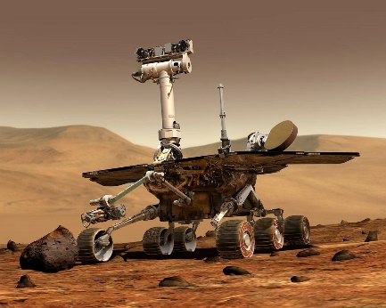 | 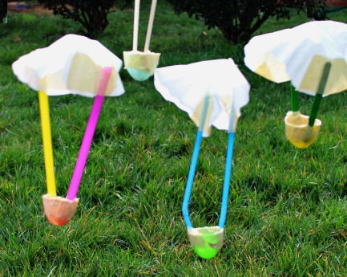 | 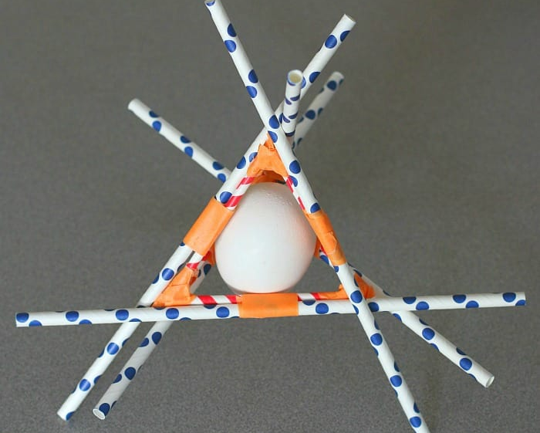

Use any of the materials provided to design and build your landing vehicle.
A successful landing includes retrieval of the egg from the landing craft.

You may purchase extra materials as shown below.
All materials have the same cost.

Sellotape  1 piece | One paper cup | One toilet roll tube
Blue Tack  1 blob | Piece of card  A5 size | Glue
Bin bag  1 piece | Newspaper  One large sheet | Kitchen roll  Two pieces
String  1m piece | Bubble wrap  One piece | Five paper clips
Cotton Wool  1 piece | One balloon | Piece of paper  A4 size

Mars Exploration Rover Launch & Landing Video

