Differentiating $y=a^{kx}$

$$y=a^{x}$$  $$\frac{dy}{dx}=lna×a^{x}$$ | $$y=a^{kx}$$  $$\frac{dy}{dx}=klna×a^{kx}$$

Proof by implicit differentiation

$$y=a^{x}$$  $$lny=ln\left(a^{x}\right)=xlna$$  $$\frac{1}{y}\frac{dy}{dx}=lna$$  $$\frac{dy}{dx}=lna×y=lna×a^{x}$$ | $$y=a^{kx}$$  $$lny=ln\left(a^{kx}\right)=kxlna$$  $$\frac{1}{y}\frac{dy}{dx}=klna$$  $$\frac{dy}{dx}=klna×y=klna×a^{kx}$$

Differentiate these…

- $y=2^{x}$
- $y=7^{x}$
- $y=π^{x}$
- $y=e^{x}$
- $y=2^{5x}$
- $y=7^{3x}$
- $y=e^{3x}$
- $y={\sqrt{3}}^{\sqrt{2}x}$
- $y={3×7}^{x}$
- $y= x2^{x}$
- $y=\frac{2^{x}}{2x}$
- $y=5^{3x}\left(x^{2}+4x\right)$
- $y=\frac{5^{x}}{5^{3x}}$
- $y=x^{x}$
- $v=\left(4×3^{t}\right)i+\left(7×5^{2t}+6t\right)j$
- ${y=2}^{\left(3^{x}\right)}$

AQA A2 Paper 1, June 2018…
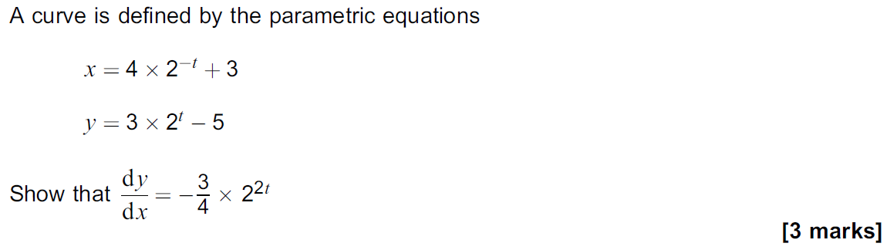
Answers…

- $\frac{dy}{dx}={ln2×2}^{x}$
- $\frac{dy}{dx}=ln7×7^{x}$
- $\frac{dy}{dx}=lnπ×π^{x}$
- $\frac{dy}{dx}=lne×e^{x}=e^{x}$
- $\frac{dy}{dx}=5ln2×2^{5x}$
- $\frac{dy}{dx}=3ln7×7^{3x}$
- $\frac{dy}{dx}=3lne×e^{3x}=3e^{3x}$
- $\frac{dy}{dx}=\sqrt{2}ln\left(\sqrt{3}\right)×{\sqrt{3}}^{\sqrt{2}x}$
- $\frac{dy}{dx}=3ln7×7^{x}$
- $\frac{dy}{dx}= xln2×2^{x}+2x$
- $\frac{dy}{dx}=\frac{2^{x}\left(2xln2-2\right)}{{\left(2x\right)}^{2}}$
- $\frac{dy}{dx}=5^{3x}\left(2x+4\right)+3ln5×5^{3x}(x^{2}+4x)$
- $\frac{dy}{dx}=-2ln5×5^{-2x}$
- $\frac{dy}{dx}=x^{x}(1+lnx)$
- $\frac{dy}{dx}=\left(4ln3×3^{x}\right)i+\left(14ln5×5^{2t}+6\right)j$
- $\frac{dy}{dx}=2^{3^{x}}×3^{x}ln2ln3$

Integrating $y=a^{kx}$

$$\int{a^{x} dx}=\frac{a^{x}}{lna}$$

$$\int{a^{kx} dx}=\frac{a^{kx}}{klna}$$

