Planetary Nebulae

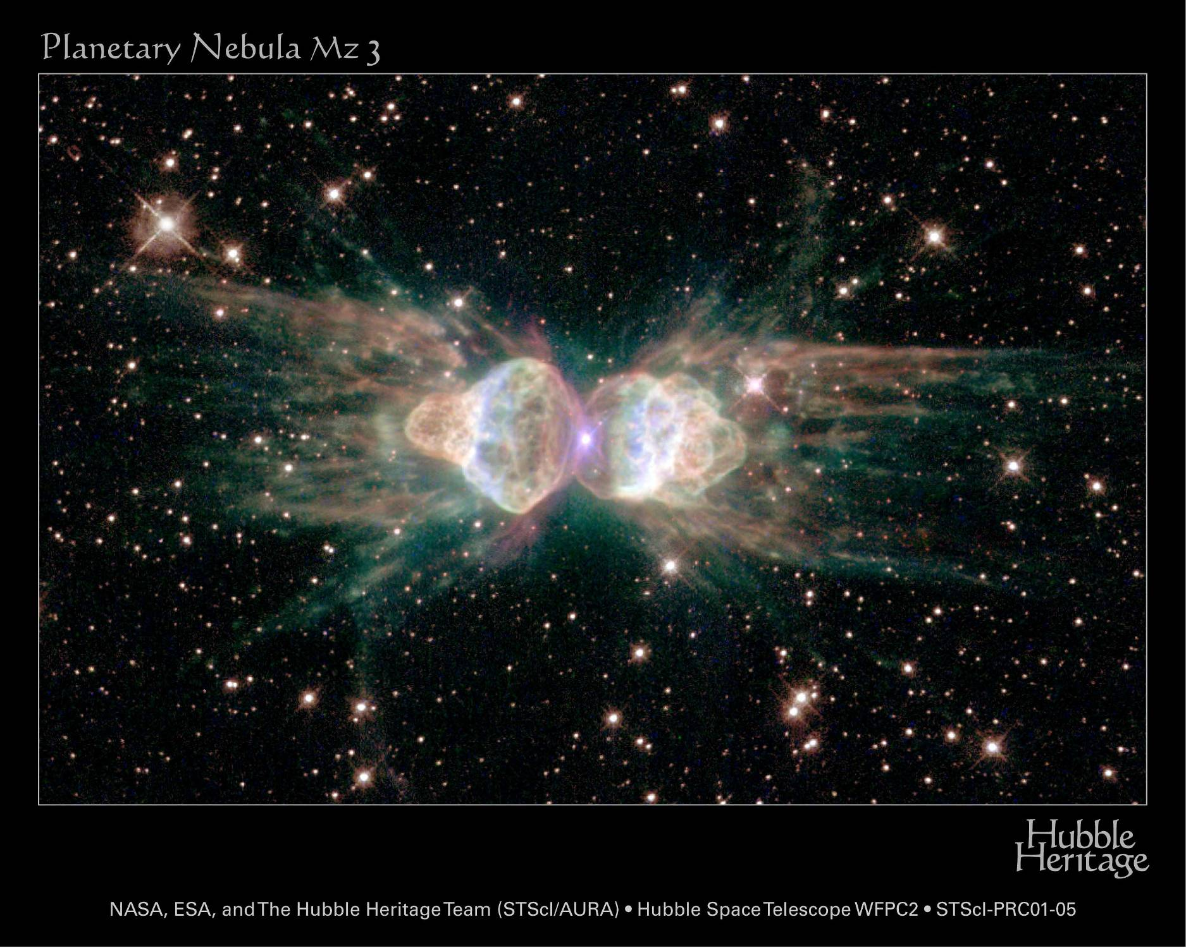

Just like astronomers, can you recreate the three-dimensional object from the two-dimensional images?
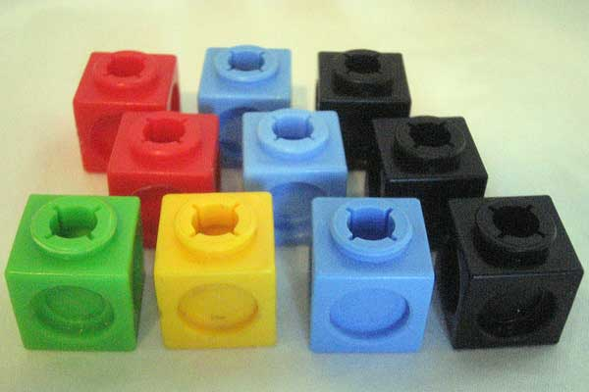

What to do here

Use the cubes to create each of the objects shown in the 2D images.
Check your construction with the image on the back of each card.
What’s this all about?!

When astronomers use the Hubble Space Telescope they obtain images of these objects from a single point of view.

Similar objects in space are orientated in different ways and appear differently even though they may really be the same.

Planetary nebulae are dying stars are can often look very different from differing angles and astronomers must work hard to recreate the objects observed from just a single image.

